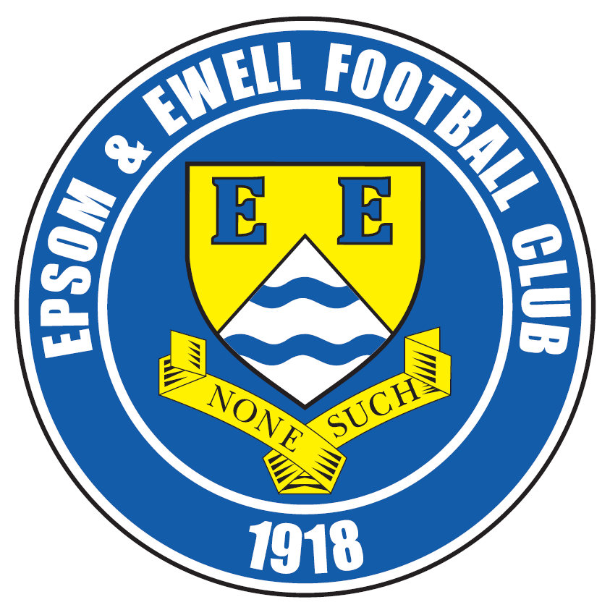 | Epsom & Ewell  24  v  Farnham Town  Saturday, 27th April 2019 – 3.00 p.m.
Good afternoon! For our final league match of the season, we welcome the players, supporters and officials of Farnham Town. At the start of the season our two clubs might well have been favourites to return to Step Five following our relegations, but both clubs have had slumps at important times and will be facing each other at this level next term too. They defeated us 4-1 in Farnham back in October so we are looking to balance matters today.

Additionally, we have the bonus of the Division One Cup Final on Monday 6th May at Meadowbank against Frimley Green and it would be great to see you all there to support our boys, who will be desperate to gain revenge for a 4-2 defeat over there in February. Remember, we battered them 3-0 here on a proper playing surface, so it should be close!

As it is our last home match of the season we have the usual features that you would expect in one of our programmes, including the conclusion of the Previous Managers series. Those who didn’t get issue 18 which was the original date of this fixture may be pleased to know that you wouldn’t have missed an instalment of that series, although we do still have copies available for those of either team who are interested. We also have the usual summaries.

Our League season has concluded with three straight home matches and most of us were here just seven days ago for our encounter with Sandhurst Town, losing 1-3 after conceding three times in the first half to kill the match as a contest. Jordan Gallagher scored our goal.

We will be holding our end of season Presentations after today’s match at around 5.15 - 5.30 so please stick around and show your appreciation. There are four trophies and you all get to vote for the Supporters Player of the Year, now known as the Dave Wilson Trophy. The Players get their version too, as does the Management Team, while the fourth award is the Club Person of the Year trophy which is determined by the Committee.

Voting forms are available at the turnstile and need to be back with a Committee Member by the final whistle today as we have to collate the scores and work out who has won before the Presentation. Please note that Club member votes count double and there is still time for you to renew your membership, just speak to any Committee Member.

Enjoy the game, our upcoming Cup Final and the summer break and we’ll see you bright and early next season with our first friendly provisionally scheduled for 9th July!!

Rich

You can follow us on social media – just see the inside cover for details.

Cover photos by Gemma Jarman

1) Hakim Griffiths scores both his and our fourth goal in the 6-4 win at Bedfont & Feltham
2) Jordan Gallagher scores our goal at Tooting Bec on 30th March
3) Jordan Gallagher scores our goal in last Saturday’s defeat to Sandhurst Town


Cherry Red Records Combined Counties League
Division One Table 2018/19
inc Tuesday 23rd April 2019 | P | W | D | L | F | A | Pts | GD | H | A

Sheerwater (C) | 34 | 24 | 5 | 5 | 90 | 40 | 77 | +50 | 2-3 | 0-3
Frimley Green | 34 | 23 | 7 | 4 | 75 | 41 | 76 | +34 | 3-0 | 2-4
Tooting Bec | 33 | 20 | 7 | 6 | 81 | 38 | 67 | +43 | 3-1 | 1-4
Farnham Town | 33 | 20 | 5 | 8 | 73 | 40 | 65 | +33 | 27/4 | 1-4
Bedfont & Feltham | 33 | 18 | 7 | 8 | 97 | 52 | 61 | +45 | 4-4 | 6-4
Sandhurst Town | 33 | 18 | 6 | 9 | 60 | 50 | 60 | +10 | 1-3 | 2-0
Ash United | 34 | 17 | 7 | 10 | 82 | 66 | 58 | +16 | 1-1 | 2-1
Epsom & Ewell | 33 | 17 | 4 | 12 | 76 | 65 | 55 | +11 | X | X
Chessington & Hook Utd | 33 | 13 | 6 | 14 | 65 | 64 | 45 | +1 | 1-2 | 4-1
British Airways | 34 | 12 | 5 | 17 | 71 | 83 | 41 | -12 | 3-2 | 2-3
Dorking Wanderers Res | 34 | 12 | 6 | 16 | 63 | 77 | 41* | -14 | 3-0 | 3-5
Godalming Town | 34 | 11 | 5 | 18 | 49 | 78 | 38 | -29 | 3-2 | 3-1
Bagshot | 34 | 10 | 5 | 19 | 39 | 93 | 35 | -54 | 7-1 | 3-0
FC Deportivo Galicia | 34 | 10 | 3 | 21 | 60 | 72 | 33 | -12 | 0-2 | 3-0
Kensington Borough | 33 | 7 | 9 | 17 | 42 | 71 | 30 | -29 | 1-1 | 1-5
Eversley & California | 33 | 8 | 3 | 22 | 63 | 84 | 27 | -21 | 1-0 | 1-2
Fleet Spurs | 34 | 7 | 5 | 22 | 55 | 86 | 26 | -31 | 1-1 | 3-2
Cove | 34 | 5 | 5 | 24 | 46 | 87 | 20 | -41 | 3-2 | 2-1

* Dorking Wanderers Reserves – 1 point deducted for playing an ineligible player

AC London (removed) | 15 | 9 | 2 | 4 | 36 | 25 | 29 | +11 | X | 6-0

Lucky Day? – 27th April
Played 21 - Won 9 Drawn 3 Lost 9 - For 35 Against 40 - PPG 1.43 - Average
Our Club record against Farnham Town
Played 18 - Won 9 Drawn 4 Lost 5 - For 31 Against 29 - PPG 1.73 - Good
Our Largest wins and losses against Farnham Town
14th November 2017 - W 3-0 - Combined Counties League Premier Division (H)
20th March 2012 - L 1-4 - Combined Counties League Premier Division (H)
20th October 2018 - L 1-4 - Combined Counties League Division One (A)
Farnham Town‘s Last Visit
14th November 2017 - W 3-0 - Combined Counties League Premier Division

Club President – Stella Lamont

Hello Everyone,

I always like to bookend each season by sponsoring our first and last league games as it gives me the opportunity to look forward and reflect. You’ll know by now that while I’m physically unable to attend our games, I’m always wholly with you in mind and spirit.

These days I follow progress live on Twitter (which is a sentence that still seems remarkable to this ninety year old), so I thought I’d end the season with a Top 10 of my monthly highlights.

- AUG 4. We begin the season on a scorching hot day with a 2-0 win at Sandhurst Town.

- SEP 29. Games that finish 3-2 when the winning team recovers a two goal deficit are always the most exciting and our away win against Fleet Spurs was no exception, particularly as we were 2-0 down with 20 minutes to go. (In December we would repeat the trick against Godalming Town – this time with only ten men.)

- OCT 25. A retweet highlighting an exhibition called Black Millwall took me down two paths of memory lane. I remembered Phil Walker and Trevor Lee as among our most skilful and valued players from the 1970s (when I began my involvement with our club), and Millwall, who signed them from us, was the first professional club I went to see in the 1950s.

- NOV 20. Elliott Thompson scores a wonder-goal in our 4-0 victory against Dorkinians, beating three players before finishing from twelve yards. “Worth the price of admission”, according to @EEFCOfficial. Shades of Maradona. (And not cocaine-fuelled. Probably.)

- DEC 22. A retweet from @TonyIncenzo sends Christmas greetings to “all the unpaid volunteers who keep football going all year at Non-League, grassroots and youth levels”. Very nicely done. No volunteers, no football. Simple as that.

- JAN 8. Following some post-hospital treatment I was able to play my part in recommending our new physio, Chantelle Farrell, to the club. (Inexplicably my agent’s fee has failed to arrive).

- FEB 16. Recovering from a half time deficit to win 3-2 away at British Airways FC, we run up a sequence of five victories in a row for the second time this season.

- MAR 9. Scott Murphy apologizes “to all supporters and people who work so hard behind the scenes” for an abject performance. A nice touch. (Personally I am amenable to an apology in the form of half a case of wine right up to six months after the original incident.)

- APR 3. I’ve always appreciated sportsmanship in the game, and the FC Deportivo Galicia keeper congratulating our supporters after we beat them 4-2 in the Esoteric Division One cup semi-final was no better example.

- APR 13. We win an extraordinary game of fluctuating fortunes, 6-4 against Bedfont and Feltham. 6-4!

Well we started the season with high hopes of promotion, and while we didn’t achieve it we do at least have a cup final to look forward to at season’s end. Congratulations to all our players and management for their collective endeavour, and for keeping me entertained at one remove.

Finally: thanks and best wishes to everyone behind the goal and behind the scenes. Love and good luck to you all. See you next season when we will do it all again.

Stella

Club Chairman – Pete Beddoe

Welcome everyone to our last league game, and on behalf of the Committee we thank our loyal supporters for their support during the season.

Suffice to say it has been a very eventful season both on and off the pitch. Our aim was to secure promotion. This was always going to be difficult as only one promotion place was guaranteed. We started very promisingly with a number of good results in the league and a good win in the FA Cup against Langney Wanderers. We also performed very well against Beckenham Town in the next round, only losing eventually after extra time in a replay. Results tended to tail off, although one excellent performance was a 6-0 win away to AC London under very difficult circumstances. Unfortunately the records for this match were expunged when AC London were removed from the league. This certainly didn’t enhance our promotion cause.

The situation both on and off the pitch became very difficult to manage and matters came to a head after a poor performance against British Airways in early October when the Committee decided that Neil Grant should be replaced by Simon Funnell, firstly as Caretaker manager and then as our full term manager at the beginning of November. Fortunately his appointment was confirmed just before my wife Maggie decided to celebrate by breaking her hip. She is now well on the way to mobility and would like to thank everyone for their best wishes for a speedy recovery.

Simon brought with him Matt Drew as Coach and Paul Marshall continued in his role as Kit Man and General Assistant to the Management Team behind the scenes. Later we acquired the services of Chantelle Farrell as our Physio. There was an immediate improvement in the team spirit of the squad which was so good to see. All in all, the Club has a very professional management team.

Simon’s style is full co-operation with all members of the Committee and his communication skills are beyond reproach. We always receive full feedback after every match whatever the result. He is very conscientious and is able to balance work and family commitments with his football duties with great ease. After his first match in charge as Caretaker Manager we embarked on a very successful run of just one defeat in 19 matches. It has tailed off recently, as Simon has often been thwarted with non-availability of players for various reasons, often at short notice.

Promotion was not to be; it was always going to be a long shot and after the defeat at Frimley Green when everyone saw that there had been a handball leading to one of their key goals, apart from any Officials, our chances were finally dashed.

However, we did beat FC Deportivo Galicia to reach the final of the CCL Division One Cup to play Frimley Green. This is being played at Meadowbank on Bank Holiday Monday 6th May (ko 3.00 pm), so please come along and support the Boys.

Our discipline on the pitch has been poor and this will need to improve especially as far as Respect bookings are concerned. Next season will see the introduction of Sin Bins; watch this space for more information on how this will work.

It would not be appropriate to single out any player for special mention; the important thing is that they all play for the Badge. I would commend to everyone attending the Presentation of the Club’s annual awards after the match today. It’s still not too late to vote.

Off the pitch the Club’s Centenary dinner was held at Epsom Golf Club in September and proved a very enjoyable occasion, thanks largely for all the hard work that Mel Tough put in.

Also off the pitch we found out that we had been selected from a list of local clubs to take part in a Photo shoot for a new FA App in conjunction with PayPal UK called Matchday and this took place in mid-February. Lee Dixon and Rachel Yankey were present and a good day was had by everybody.

I’d like to thank Richard for organising the event, Chipstead FC for providing the facility, Simon, Matt & Paul for organising the players and finally Jessica Ramsey who was our main contact and who was very generous in her contributions to the Club.

After the Final we can look forward to a short break before pre-season starts in earnest in July. For details of this please consult the Website in the next couple of weeks.

The Club AGM is planned for Sunday 21 July; more details later, again on the Website.

The next season starts at the beginning of August and our aim has to be promotion and of course an improvement in our discipline on the pitch. I’m reliably informed that next season there will be more guaranteed promotion places, but it will be a challenge with many good teams around.

On the relocation front we are still pursuing our site at HRA, as our primary venue, although our Councillor contacts are still of the opinion that the site is not suitable because of its overuse for other activities which we do not agree; somehow we have to disabuse them of this view. This view has come about from the findings of a working party of Councillors assessing the suitability of sites, both public & private, in the Borough. On a more positive note this review has identified another site as being suitable in their opinion after previously been informed it wasn’t because of restrictive covenants on the use of the land. I can elaborate on this if anyone wants to know the latest on this verbally. We are in the process of reviewing their assessments and will feed this information back to them for their consideration.

As we all know time is the essence and the funds won’t last forever. We will renew our attempts with vigour to get a decision once Local Elections are over, which always tends to delay matters.

Before finishing I’d like to thank everyone involved in the Club for all their excellent work often under very difficult personal and work conditions; Steve Dyke our Treasurer for his financial acumen in keeping the Club viable and for his invaluable advice in his position as Vice Chairman; Richard Lambert, our Media Officer, for providing our outstanding Club programme , operating our website and for all his assistance; Paul Marshall who has combined his duties as Kit Man and General Assistant to Simon, Matt & Chantelle and with his hospitality duties. As I’ve said before Paul is invaluable in the car when locating an away ground when we’re 100 yards away when the Sat Nav no longer functions! Mel Tough has dealt with Membership matters, organised the AGM, dealing with kit & FA Charter issues and of course ensured the Centenary dinner was a great success. Gary Jarman has provided business acumen and has helped us obtain sponsorship through his contacts. His wife Gemma has provided excellent photos as usual and co-operates with Richard on social media aspects. Also thanks to George Holland for his individual and idiomatic press reports and for helping in various ways on Match Days; Sam Dyke for his skilful use of a temperamental PA system on match days; and finally Karen Martyn for providing the sandwiches and of course everybody else who has helped. Finally I’d like to thank all our supporters for their invaluable and loyal support; without them we can’t continue. In addition many thanks to Dave Ellins of the Limited Company for providing funds and financial advice and overseeing our accounts.

I’d also like the thank Chipstead for all their support; in particular Bretty for providing an excellent pitch whatever the weather; Keith, Simon & Neil and their team for providing all the match day facilities; Terry for his many kindnesses throughout the season; and finally Heather for all her liaising in ensuring our fixtures can be fitted in.

I think that’s enough from me, enjoy the rest of the season, have a good Summer break and come back refreshed for the next season.

With sincere regards,

Pete

From behind the goal
Sheerwater 3-0 Epsom & Ewell
Combined Counties League – Division One - Tuesday 19th March 2019

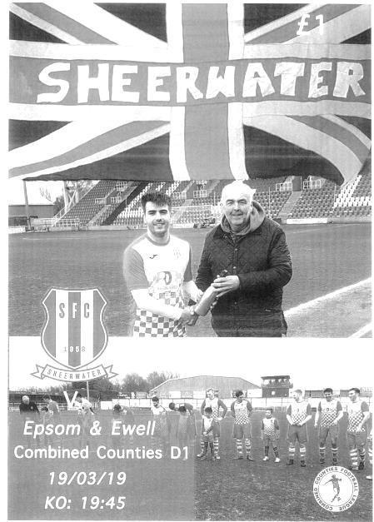
Losing run continues at Kingfield

It may be the Laithwaite Community Stadium these days, but to football fans of a certain age, Woking FC's home will always be known as Kingfield, and it was at that imposing and cavernous looking venue that a Step Six league match took place in front of 78 spectators when Sheerwater boosted their chances of promotion, at the same time extending our run of consecutive losses to five. It also means that our last four visits to the ground have ended 0-6,0-5,0-4 and now 0-3 following our last goal at the venue back in August 1983.

We had yet further reshuffles in our team with Conor Young still struggling with a knee injury so Josh Woodcock came back in between the posts, hoping to keep another clean sheet, but this was a tough ask, seeing as we haven't had one since 29th December of last year! We named our fifth different left back in five matches, as Ben Chick followed Sam Morgan, Reisse Griffin, Luke Elgar and Olly Martinez into the role, while Jamie Watts returned at the back, resulting in Scott Murphy moving into midfield for the first time in weeks in place of the suspended Jake Robinson. Rob Hendry returned up front and our recently re-acquisition Jordan Gallagher came in on the left wing. With the exception of the reliable Young and the absent Reisse Griffin, it was as strong a team as we could have named with a decent strength bench for the first time in a while too.

The match started very evenly on a perfect evening for football with both teams passing the ball around, although the hosts had an early chance in the third minute when a looping left wing cross was headed over the bar by a Sheerwater attacker. Gallagher and Adam Heagney, both products of the Leatherhead Academy who were born just two days apart, both had attempts on goal from distance, but the ball was in the Epsom net in the 19th minute, fortunately ruled out for an offside decision.

We had a good chance in the 32nd minute when Chick overlapped well and pulled his cross back for Bobby Bennett in a good position, but his first touch let him down and sent him wide, from where he could only deliver a tame cross. Two minutes later we were behind for real as the Sheerwater right winger made a similar run to Chick's and with a similar pull back, but Chris Machay's control and finish from 15 yards were clinical, bending the ball beyond the outstretched Woodcock into the far corner of the net.

I could say that we were unfortunate to be behind, as we had given as good as we got to this point, but we did look strangely tentative going forward, despite an impressive looking front four that wouldn't be out of place in Step Five football and we weren't really asking the opposition

enough questions, although when we were attacking, Neil Roissetter appeared to be almost everywhere to snuff out many of our moves before they became threatening. In fact it could have been worse as we nearly conceded a second goal when a deep cross from the left was beyond Connelly, but Danny Taylor miscontrolled the ball and we escaped with the damage at just one goal as the teams went off for the interval.

In the second half, the home side showed us how it should be done, attacking us on both flanks and often having a man over as they stretched us from side to side and scored twice more during the period. Before that we had other scares when Timmy Taylor, one of a number of Sheerwater players who used to call Knaphill his home, drove the ball across goal just inches ahead of the incoming attacker and in the 50th minute they had a fair looking shout for a penalty but the referee wasn't really up with play and probably wasn't in the best position to make a decision, and play continued. Then within a minute Taylor saw his shot blocked on the line by an Epsom defender after Woodcock had come out but been beaten to an earlier ball in.

We were creating little to this point. Hendry got through briefly, but he was well marshalled by two defenders who came across and denied him the opportunity to do anything more than toe the ball towards Andy Rider. Chin made a timely interception of a dangerous cross with Taylor waiting, but the pressure was building and in the 58th minute the lead was extended. I thought we should have had a free kick when Hendry was upended in the middle of the park, but it was not given and seconds later Sheerwater were awarded one. The delivery into the box was not cleared and Shane Rideout smashed the loose ball into the net from ten yards out. Four minutes later we left a huge gap that Danny Taylor just strolled through and he gave Woodcock no chance from close range to make it 3-0.

It was beginning to look a little reminiscent of our recent collapses at Frimley Green and Kensington Borough as the home side pressed for a fourth goal. Liam Roberts came on for the quiet Carney and Chick made good ground again on the left but his cross was just too high for Hendry who could only head the ball over the bar at full stretch. Three inches lower and we would have had a goal back. However, Danny Taylor then missed a sitter from not far out moments later!

Elliott Thompson came on for Chick to make his fiftieth appearance for our club, although the match was over as a contest by then. We should have had a penalty in the 88th minute when Bennett was dragged back, spun around and then knocked to the floor by a defender, but bizarrely the Assistant gave a corner instead when the ball hadn't even crossed the line with the referee equally unimpressed (and unimpressing!). It would have given Bennett the chance to extend our scoring run in every league match this season, but would have been of little other consolation and to be honest, I'm not sure that we did enough to deserve a goal on the night.

If that sounds critical, that is maybe a little harsh as this team were the best we had played against all season. Unlike recent calamities where we could point to a number of players being out, we were virtually at full strength yet once we went behind, there appeared to be very little opportunity to get back into the match against a side that had also beaten Bedfont & Feltham 4-1 just three days previously. Frimley Green may well win their games in hand and take the title this season, but Sheerwater are the best team in this league right now and we found out exactly why first hand at Kingfield.

Epsom and Ewell: Josh Woodcock, Louis Chin, Ben Chick, Adam Heagney,
Jamie Watts, Lloyd Connelly, Bobby Bennett, Scott Murphy (c), Billy Carney,
Rob Hendry, Jordan Gallagher

Subs: Liam Roberts for Carney (64), Elliott Thompson for Chick (76),
Todd Murphy for Watts (91)

Club Manager – Simon Funnell
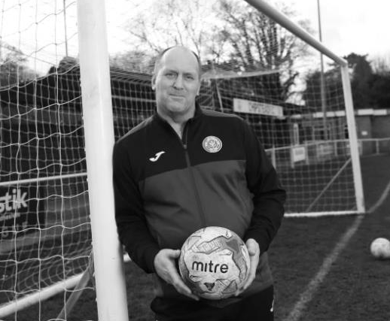
Good afternoon everyone and welcome to our last league game of the season.

When I first arrived at Epsom and Ewell I was delighted to find I had a healthy squad to work with so I brought in just a few new players.

We started well with a good run of winning games but that didn’t last and we’ve not ended so well.

The recent results have not been as good as I had hoped and sadly we are not in contention for promotion as it looked like we may have been earlier in the season. I was delighted when we got into the top four, but just couldn’t keep the form up.

Finishing in the top half of the table is not a disgrace, but gives us plenty of room for improvement next season. With my increased knowledge of how the club and the players work I am confident that we can push forward in 2019/20 season.

We missed some key players this year at important times through injury, suspension, work and other reasons, so hopefully we can improve on that front next season.

I would like to thank my players, Paul the Kit Man, the coaching staff, Chantelle the Physio, the Committee, Gemma Jarman our Club Photographer, and the supporters for everything they have done for me and the team since I took over.

Of course we still have the Cup Final to look forward to on Monday 6th May and I hope to see you all there.

With thanks and best wishes for the summer break.

Simon

From behind the goal
East Grinstead Town 3-1 Epsom & Ewell – no programme produced
Mid-season friendly - Tuesday 26th March 2019

Tough challenge for Salts

A hastily arranged mid-season friendly was arranged with one of our Manager's former teams, East Grinstead Town and the players made it down to a chilly East Court with varying degrees of success, as some got slightly lost on the way, while others were delayed both by car and train as they joined the rush hour queues from London. Our starting line up was therefore not as originally intended, while the opposition also tried out some of their younger players in the opening forty-five minutes.

Around 30 people were present to witness an entertaining first half of football with two evenly matched teams playing some nice football at times, although we took the lead in the 11th minute when Jordan Gallagher robbed a defender on the edge of the box, then showed good strength to hold him off before hitting the ball back across the keeper, who was slightly wrong footed in the process.

The hosts had chances too, in particular just three minutes after we had taken the lead, when we were caught out by a short corner and when the delivery came in, Josh Woodcock did well to block the unmarked header which was then cleared. We had a concern when Bobby Bennett pulled up injured just before half time and it is hoped that he will be ok for Saturday, but would have gone in at half time very happy with our performance to that point.

Of course with any friendly, we might well have been playing a Step Four team, but it all really depends on how many of that club's first eleven are actually out there that gives you an idea of the opponent's real strength and they made a couple of changes at half time to that effect to the extent that, according to their keeper, it was pretty much a first team squad that were on the field, if not necessarily their starting eleven.

This became apparent in the second half as they attacked us down the slope and we found ourselves restricted to very little in the way of chances. However, the defenders were holding on well and as is so often the case, just when it looked as though we had weathered the storm, they equalised, adding two more goals in quick succession over the following six minutes. A right wing delivery was forced in at the near post by Greg Cundle beyond the unlucky Woodcock who almost kept it out in the 70th minute and after a disallowed goal for offside a clumsy challenge on Cundle in the 73rd minute enabled him to score his second of the night from the spot.

In the 76th minute a strike from close range by Robin Dean gave Woodcock no chance, although a couple of fine saves prevented the scoreline being larger by the end as the opposition showed us why they are an Isthmian League club these days. We had a couple of opportunities towards the end of the match from Jake Robinson and Liam Roberts but they were both from distance and didn't trouble their keeper.

Overall though it was a good work out for an Epsom team that has been short of football in recent weeks and with a tough test coming up at Tooting Bec on Saturday, it is hoped that everyone will have come through unscathed.

Epsom and Ewell: Josh Woodcock, Ryan Sullivan, Alex Sargeant, Elliott Thompson,
Adam Heagney (c), Lloyd Connelly, Bobby Bennett, Hakim Griffiths, Billy Carney,
Jordan Gallagher, Liam Roberts

Subs: Jake Robinson for Bennett (40), Louis Chin for Sullivan (HT), Ben Chick for Carney (HT),
Tre Trowers for Thompson (66), George Brown for Sargeant (68),
Sullivan back on for Gallagher (77), Sargeant back on for Roberts (85)

From behind the goal
Tooting Bec 4-1 Epsom & Ewell
Combined Counties League – Division One - Saturday 30th March 2019

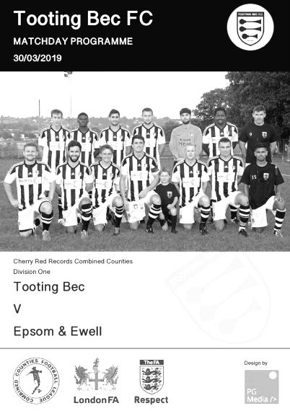
Defeat at Bec confirms a blank March

Our fourth match this month ended with our fourth defeat at Grand Drive; a soulless and desperately dishevelled venue that has seen better days and not for some time either. I could easily lay some blame for our defeat on its rutted and uneven playing surface that makes a lottery of an FA Ground grading system that takes no interest in a green bit that is as equally important as the number of seats or the size of the dressing rooms, but it was the same for both sides and the real reason for the defeat lies a lot closer to home, as a succession of poor decisions and a failure to adapt to the playing conditions led directly to our downfall.

Following our last match at Sheerwater eleven days previously we made a number of changes. Reisse Griffin came back in at left back for the unavailable Ben Chick while Elliott Thompson came in for the absent Adam Heagney. Further forward, Hakim Griffiths replaced the working Rob Hendry and Jake Robinson returned from his one match suspension in place of the injured Bobby Bennett.

A small crowd, almost all of which were following the Salts, were in for another frustrating day as we got off to yet another slow start. Liam Roberts did well on the left in the opening minute but over hit his cross beyond waiting teammates and we nearly went behind in the fourth minute when the home team came down the right and a low cross was struck over the bar from close range. Lloyd Connelly made an important clearance four minutes later but was the victim of a horrible bounce allowing a Bec striker through on goal. Josh Woodcock did well to force him wide, but he then just rolled the ball across to Alistair Wilshere who knocked the ball past a couple of defenders into the net in just the 13th minute.

Five minutes later it got worse as we appeared to have cleared the immediate danger, only for Darius Heravi to lob the ball back in over Woodcock and into the net from outside the area. At 2-0 down we started to fight back. Roberts put in a good low shot which was well saved by Zdenek Macacek for a corner but at the other end Woodcock then made an even better save from a powerful shot on the left which he tipped up onto the bar with Connelly heading the loose ball away.

The play switched from end to end as both teams realised that a more direct approach would pay dividends, although in the 24th minute Griffiths proved that it was still possible to produce great skill at times as he twisted and turned a number of defenders in the box before laying the ball back for Scott Murphy to chip to the far post. Jordan Gallagher was waiting in space but instead of going for the header he chose to swing a foot at the ball, missing it completely! Fortunately Roberts was first to the loose ball and he fed Gallagher again who did much better this time, although the angle was a narrow one and his low drive pinged off the foot of the post and was

cleared. Still, seven minutes later we did open our account, this time after Jamie Watts had blocked a shot on goal from the home side. The ball was sent into the Bec half where Gallagher had a lot of room but still had much to do. He cut in from the left and expertly slotted the ball under the advancing Macacek to reduce the deficit to 2-1.

We continued to press our hosts for a while in search of an equaliser and Connelly nearly got his header on target from a Gallagher free kick but it was a difficult chance. As the half ended our wall did its job in blocking a free kick from the opponents but there was no denying we'd been second best and deserved to be behind at the break.

Going down the hill in the second half is usually the best thing to do at Grand Drive and we started fairly well, although did nearly concede to an unmarked header from a corner but Woodcock was well-positioned to make the save. Griffiths was off balance and sliced his shot at goal after making another half chance out of nothing before Gallagher's delivery was missed at the far post by Robinson who failed to make contact in a good position, although a defender may have got a touch to the ball first. Robinson then picked up a harsh yellow card for a clumsy but not malicious challenge.

However, any good momentum that we were building came crashing down in the 62nd minute as we conceded a horrible third goal, incredibly from our own throw on. It's not even clear looking back exactly what happened, but almost immediately they were bearing down on our goal. Their striker went down far too easily under a challenge which didn't look like a foul, but the ball ran to the unmarked Heravi in the middle of the goal and he gave Woodcock no chance. The referee played a good advantage to allow the goal to stand, although worryingly it looked as though he might have been about to blow for the original challenge which would have been an awful decision. To be fair though, the real issue here was a complete lack of defence and it has happened a bit too much recently.

Ryan Sullivan came on as our second substitute after Billy Carney and we reverted to three at the back in an attempt to get more men forward. In fact Sullivan was lucky to avoid injury, following a naughty studs up challenge that happened right in front of the referee for which not even a free kick was given and our frustrating day took further turns for the worse as we conceded a fourth when Tom field's unmarked header from a corner was well blocked by Woodcock only for Kieran Patel to force the loose ball in from close range. Then in the final minute of normal time Roberts picked up a yellow card for appearing to leave his foot in a little late on a defender. On another day it might not have mattered, but he was already on a yellow card for what was a very quiet comment to the referee some twenty minutes earlier. He will now miss two games as this was his second red card of the season.

All in all it was a very disappointing day out for Salts fans. This was our sixth loss in a row; something we didn't achieve even during the horror of our Centenary season and another loss this Wednesday would equal our worst run since 2004/05. It is to be hoped that trip to FC Deportivo Galicia in the Division One Cup Semi-Final produces a different result; at least it will be on a surface conducive to good football, although we will have to improve quite a bit individually too if we want to progress to the final of that competition and on Saturday's showing, that could prove to be our biggest challenge.

Epsom and Ewell: Josh Woodcock, Louis Chin, Reisse Griffin, Elliott Thompson,
Jamie Watts, Lloyd Connelly, Jake Robinson, Scott Murphy, © Hakim Griffiths,
Jordan Gallagher, Liam Roberts

Subs: Billy Carney for Griffiths (57), Ryan Sullivan for Chin (77),
Todd Murphy for Connelly (81)

From behind the goal
FC Deportivo Galicia 2-4 Epsom & Ewell
Esoteric Division One Cup - Wednesday 3rd April 2019

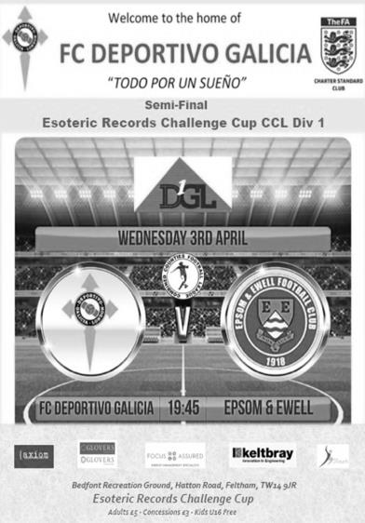
Salts storm to Cup Final despite officiating howlers

A run of six straight losses was finally broken in style by a rampant Epsom team that was missing three ineligible players but still totally dominated their hosts and would have won by more, but for a momentum killing and totally incorrect sending off midway through the second half.

There were a number of changes from our 4-1 defeat at Tooting Bec on Saturday and our players will also have been pleased to know that the artificial surface at the Bedfont Sports Club would suit their style of play far better. Jordan Gallagher, Louis Chin and Jamie Watts were all unable to take part, while Ben Chick and Jake Robinson were also unavailable for various reasons but the team still looked strong with attacking threats Rob Hendry and Bobby Bennett both available after work and injury respectively and with Hakim Griffiths just behind the fully fit Billy Carney up front there were nearly fifty goals amongst them. At the back Adam Heagney returned to the line-up and Scott Murphy moved back into defence so that the returning Ryan Sullivan could play in the middle of the park alongside Elliott Thompson.

Right from the start you could see the intent from our players as they pressed the Galicians back. Sullivan was first to strike from twenty yards but home keeper Steve Kamgoue wasn't troubled. He did have a little more trouble in the 11th minute when he dropped a Hendry corner which Lloyd Connelly hooked just over the bar, but it was a difficult chance with players on the line. A low shot from Hendry was gathered at the second attempt before Carney also hit the target but saw his shot saved also.

We could have gone ahead in the 22nd minute. Griffiths hit a swerving shot from twenty yards but Kamgoue produced an absolutely brilliant save, despite going the wrong way initially, to divert the ball over the bar with his left hand. On another day you might have begun to worry that it might not be our day and the hosts then threatened briefly with a couple of strikes that were not too far away from our goal where Josh Woodcock was having a very quiet night.

Finally though we made the breakthrough. Griffiths was brought down on the edge of the box and rather bizarrely the kick was delayed as the Mo El Gomri decided to run back and join the wall just as the kick was about to be taken which earned him a yellow card. However, in the 37th minute Hendry curled the ball from 20 yards into the top corner, grazing Kamgoue's left hand on its way in. It was another peach of a strike to add to Hendo's

already impressive portfolio this season. However, within a minute our opponents were nearly back on level terms as a low shot forced Woodcock to make a diving intervention, tipping the ball back into play off the post.

We had our first controversy in the 41st minute when Kamgoue went out to reach the ball and Carney collided with him. It looked as though our striker had stumbled into him, but he didn't show a lot of remorse for the collision and the obligatory scuffle followed. Without all the reaction, and a hint at least of an apology, I think our man might have got away with it, but the decision would come back it him in the worst way possible later on.

Kamgoue appeared to receive a dead leg and required quite a bit of treatment and as a result it was in the fourth minute of injury time that we extended our lead when Heagney's corner was met by Griffin in a central position and criminally unmarked as he guided his header into the far corner of the net.

The contest was almost over as long as we did nothing silly at the start of the second half and in the 50th minute it was the hosts that made the crucial error as a defender failed to clear Griffin's run which he then continued and although his powerful shot was well parried, the loose ball ran to Griffiths who sidefooted the ball into the roof of the net from about twelve yards, just clipping a defender on the way in. Five minutes later it was 4-0 as a fine move started out on the right and involving a number of players finished with Carney supplying Hendry with a ball across the box from right to left and from twelve yards out and going slightly away from goal he wrapped his foot around the ball to score with a stunning low drive back across Kamgoue.

The opposition pushed forward but we were opening them up at will. Sullivan broke through and nearly scored but his attempt was blocked by Kamgoue with the loose ball being sent just wide by Carney. Then in the 65th minute Carney was tripped as he rounded Kamgoue for a penalty. Or so we thought! In a quite incredible show of ineptitude from the officials the referee, after consulting with his equally clueless assistant somehow decided that Carney had decided to dive instead of rolling the ball into the net and gave him a second yellow card. This was the single worst decision I have seen this season as not only could you hear the contact, you could see it. If you'd actually been looking. Carney will now serve a one match ban, although mercifully it will not affect his participation in the Cup Final to which we were surely headed by this stage.

And despite two goals back in the 78th and 79th minute from our hosts, and a number of free kicks ironically awarded for trips, one of which was shown to the wrong Deportivo Galicia player, the result was never in danger. At the end of the match Kamgoue came behind the goal and despite his obvious disappointment at missing out on a Cup Final, shook every one of us by the hand and also confirmed to me what everyone already knew; that he had made contact with Carney. Fortunately it made no difference to the result on this occasion, but what should have been a memory of a six or maybe seven goal win will instead be remembered in years to come for a nonsensical sending off and a class act of sportsmanship from Kamgoue. Hopefully the Cup Final against either Frimley Green or Fleet Spurs at the new Meadowbank Stadium will not be tarnished in the same way.

Epsom and Ewell: Josh Woodcock, Adam Heagney, Reisse Griffin, Ryan Sullivan, Lloyd Connelly, Elliott Thompson, Bobby Bennett, Scott Murphy, © Billy Carney, Hakim Griffiths, Rob Hendry

Subs: Liam Roberts for Griffiths (64), Luke Elgar for Heagney (70)

Esoteric League Division One Challenge Cup
Second Round
Eversley & California | 2-3 | Bedfont & Feltham
Epsom & Ewell | 1-0 | Sandhurst Town
Tooting Bec | 4-1 | Ash United
Kensington Borough | 0-2 | FC Deportivo Galicia
Sheerwater | 2-3 | Chessington & Hook United
Fleet Spurs | 0-0 - 4-3p | Cove
Dorking Wanderers | 1-2 | Frimley Green
Godalming Town | 6-0 | Bagshot
Quarter-Finals
Tooting Bec | 0-2 | Frimley Green
Bedfont & Feltham | 1-2 | Epsom & Ewell
FC Deportivo Galicia | 5-1 | Godalming Town
Fleet Spurs | 0-0 – 4-3p | Chessington & Hook United
Semi-Finals
Frimley Green | 6-1 | Fleet Spurs
FC Deportivo Galicia | 2-4 | Epsom & Ewell
Final
at Meadowbank Stadium, Dorking Wanderers FC
6th May 2019 – 3pm
Epsom & Ewell | V | Frimley Green

Recent Results and Remaining Fixtures for the season
Combined Counties League – Tuesday 2nd April 2019
Bagshot | 0-4 | Sandhurst Town
Tooting Bec | 4-3 | British Airways
Esoteric Division One Cup Semi-Final – Wednesday 3rd April 2019
FC Deportivo Galicia | 2-4 | Epsom & Ewell
Combined Counties League – Saturday 6th April 2019
Ash United | 3-1 | Bedfont & Feltham
British Airways | 0-1 | Sheerwater
Cove | 2-5 | Eversley & California
Epsom & Ewell | 1-1 | Fleet Spurs
FC Deportivo Galicia | 2-0 | Dorking Wanderers Reserves
Recent Results and Remaining Fixtures for the season
Combined Counties League – Saturday 6th April 2019
Frimley Green | 3-2 | Chessington & Hook United
Godalming Town | 1-5 | Tooting Bec
Sandhurst Town | 1-0 | Kensington Borough
Combined Counties League – Tuesday 9th April 2019
Farnham Town | 6-0 | FC Deportivo Galicia
Combined Counties League – Saturday 13th April 2019
Bedfont & Feltham | 4-6 | Epsom & Ewell
Chessington & Hook United | 1-2 | Godalming Town
Dorking Wanderers Reserves | 3-0 | Bagshot
Eversley & California | 3-0 | Kensington Borough
Farnham Town | 1-3 | Frimley Green
FC Deportivo Galicia | 2-3 | British Airways
Fleet Spurs | 2-2 | Sandhurst Town
Sheerwater | 3-1 | Ash United
Tooting Bec | 7-1 | Cove
Esoteric Division One Cup Semi-Final – Tuesday 16th April 2019
Frimley Green | 6-1 | Fleet Spurs
Combined Counties League – Tuesday 16th April 2019
Epsom & Ewell | 0-2 | FC Deportivo Galicia
Combined Counties League – Saturday 20th April 2019
Ash United | 3-1 | Chessington & Hook United
Epsom & Ewell | 1-3 | Sandhurst Town
Farnham Town | 3-1 | Bedfont & Feltham
Frimley Green | 2-1 | Kensington Borough
Combined Counties League – Tuesday 23rd April 2019
Chessington & Hook United | 3-1 | FC Deportivo Galicia
Tooting Bec | 1-0 | Frimley Green
Combined Counties League – Saturday 27th April 2019
Epsom & Ewell | V | Farnham Town
Eversley & California | V | Chessington & Hook United
Kensington Borough | V | Bedfont & Feltham
Tooting Bec | V | Sandhurst Town
Esoteric Division One Cup Final – Monday 6th May 2019
Epsom & Ewell | V | Frimley Green

This Day in History – 27th April
Date | Day | Competition |  | Opponents |  | Scorers
27/04/27 | Wed | Surrey Senior League | A | Walton | 3-2 | H.Westlake (pen), J.Parr, F.Behn
27/04/29 | Sat | London League | A | Grays Athletic | 1-2 | F.Behn
27/04/31 | Mon | London League | A | Whyteleafe Albion | 2-1 | T.Jones (2)
27/04/33 | Thur | London League | A | Park Royal | 2-1 | L.Marlow (2)
27/04/38 | Wed | London League | A | Tilbury | 2-4 | J.Jones, B.Randall
27/04/46 | Sat | London League | A | De Havilland | 4-1 | B.Peacock (2), F.Chitty, S.Scott
27/04/57 | Sat | Corinthian Memorial Shield Final | N | Maidenhead United | 0-2
27/04/63 | Sat | Corinthian League | H | Horsham | 2-2 | P.Hall, A.Pollington
27/04/66 | Wed | Athenian League 2 | A | Ware | 1-2 | K.Welham
27/04/68 | Sat | Athenian League Division Two Cup Final 1st leg | A | Edmonton | 0-3
27/04/74 | Sat | Surrey Senior League | H | Chobham | 2-0 | D.Ritman (2)
27/04/82 | Tue | Isthmian League 1 | A | Clapton | 1-2 | S.Hill
27/04/85 | Sat | Isthmian League  Premier Division | H | Hendon | 1-1 | T.Tuite
27/04/88 | Wed | Isthmian League 2s | A | Horsham | 1-1 | B.Perkins
27/04/91 | Sat | Isthmian League 2s | H | Hampton | 3-2 | R.Purvis, A.Boxall, o.g.
27/04/96 | Sat | Isthmian League 3 | A | Lewes | 3-2 | B.Forey (2), A.Boxall
27/04/98 | Mon | Isthmian League 3 | H | Harlow Town | 2-3 | A.Boxall, P.Bunter
27/04/99 | Tue | Isthmian League 3 | H | Croydon Athletic | 2-0 | P.Bunter, J.Tome
27/04/02 | Sat | Isthmian League 3 | A | Flackwell Heath | 2-1 | S.Huckle, K.Webb
27/04/10 | Tue | Combined Counties Premier Division | H | Raynes Park Vale | 0-2
27/04/13 | Sat | Combined Counties Premier Division | H | Cove | 1-6 | M.Jarman
Historical Decades
90 years ago – Epsom Town F.C.
27/04/29 | Sat | London League | A | Grays Athletic | 1-2 | F.Behn
80 years ago – Epsom F.C.
26/04/39 | Wed | London League | H | Finchley | 2-0 | A.Curtis (pen), J.Jones
70 years ago – Epsom F.C.
25/04/49 | Mon | Friendly | A | Hounslow Town | 2-1 | F.Marshall, E.Watkins
60 years ago – Epsom F.C.
25/04/59 | Sat | Friendly | H | Ulysses | 1-1 | B.Lambert
50 years ago – Epsom & Ewell F.C.
29/04/69 | Tue | Athenian League 2 | H | Edmonton | 2-1 | A.Thompson, E.Norman
40 years ago – Epsom & Ewell F.C.
28/04/79 | Sat | Isthmian League 1 | A | Bishop's Stortford | 1-2 | D.Walker
30 years ago – Epsom & Ewell F.C.
25/04/89 | Tue | Isthmian League 2s | A | Southall | 0-2
20 years ago – Epsom & Ewell F.C.
27/04/99 | Tue | Isthmian League 3 | H | Croydon Athletic | 2-0 | P.Bunter, J.Tome
10 years ago – Epsom & Ewell F.C.
28/04/09 | Tue | Combined Counties Premier Division | A | Camberley Town | 2-3 | R.Burns, A.Amfo-Brobbey

History Corner – 27th April
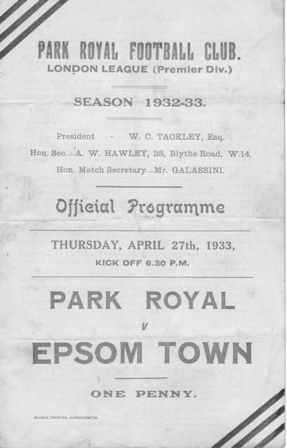
On this day in history we have played twenty-one matches, yet the first seven were all away from home and we didn’t host a match on this date until 1963!

86 years ago today we became the first club to win a London League match at Park Royal with a 2-1 victory at Coronation Road. The Royalists had won the London League the previous season without losing a match, and they would go on to win it for the next three seasons including this one. However, we were the first club to beat them in a League match when we won 5-3 in December 1932 with two goals from Reg Marlow and this became their second defeat as a pair of goals from Leslie Marlow (no relation) condemned them to their first ever home league defeat. They’d lose 2-1 the next night at Hendon (no relation to the current club) and those three matches were all they lost as we had to settle for runners-up for the second year in a row.

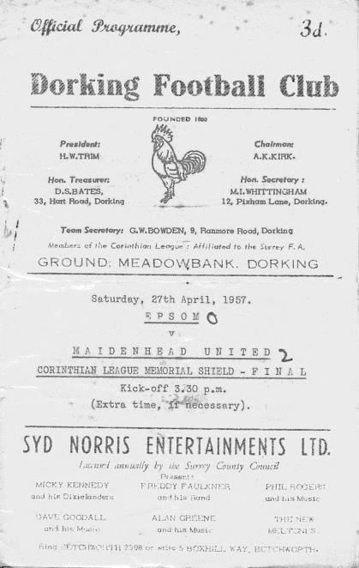
62 years ago today Epsom suffered a real end of season collapse. We went into the final week of the season looking forward to a League Cup Final and with every chance of the Corinthian League title. In Johnny Bangs we had a superb scorer who had 53 goals by this stage, even if it was wrongly reported in the Press at the time as 55 and beating the Bill Goddard post war record of 54. Trust me, it wasn’t!

And the irony was that he would never reach that mark. Bangs picked up an early injury in the League Cup Final, known as the Memorial Shield in those days and wasn’t a factor as Maidenhead United won the Cup 2-0 at Dorking’s still new, old Meadowbank ground! Regrettably this was then followed by league defeats home and away to Eastbourne and then 1-3 at home to Maidstone United, which actually left us in fourth place at the end of the season. He didn’t score in any of them.

37 years ago today Epsom were narrowly defeated at relegated Clapton. Despite a goal from Steve Hill, we conceded twice in a rearranged match after the original game had been postponed. On a personal note, this was the last match I missed as a supporter for thirteen and a half years; a tally of 696 consecutive games before missing a match in October 1995, ironically also against Clapton!

17 years ago today we visited Flackwell Heath, knowing that as long as we avoided a two goal defeat we’d be promoted. In the end it became our fourth straight win as two early goals left us cruising, despite conceding a late goal and we went up to the Isthmian League First Division South. It was also the last time the club ever chartered two coaches as it was my Stag Day and we had a few more supporters coming along. Maybe I need to have another

Above and Below
Surrey Elite League Table
incl Monday 22nd April | P | W | D | L | F | A | Pts | GD
AFC Cubo ( C ) | 28 | 19 | 4 | 5 | 86 | 34 | 61 | +52
Spartans Youth | 28 | 17 | 7 | 4 | 75 | 36 | 58 | +39
Battersea Ironsides | 28 | 17 | 5 | 6 | 83 | 45 | 56 | +38
Westside ( Promoted ) | 28 | 16 | 7 | 5 | 62 | 33 | 55 | +29
Chessington KC | 27 | 15 | 3 | 9 | 70 | 58 | 48 | +12
Merrow | 28 | 12 | 6 | 10 | 60 | 48 | 42 | +12
Staines Lammas | 27 | 12 | 5 | 10 | 62 | 44 | 41 | +18
Royal Holloway Old Boys | 27 | 12 | 5 | 10 | 59 | 41 | 41 | +18
Horsley | 26 | 13 | 2 | 11 | 79 | 65 | 41 | +14
NPL | 28 | 10 | 7 | 11 | 60 | 58 | 37 | +2
Worcester Park | 27 | 7 | 6 | 14 | 50 | 75 | 27 | -25
Ripley Village | 28 | 6 | 6 | 16 | 41 | 86 | 24 | -45
AFC Spelthorne Sports | 28 | 4 | 10 | 14 | 40 | 66 | 22 | -26
Farleigh Rovers | 28 | 7 | 1 | 20 | 39 | 89 | 22 | -50
West End Village | 28 | 2 | 2 | 24 | 39 | 127 | 8 | -88
Godalming & Farncombe | Resigned after one match
When we last looked at this division, I advised that two teams were scheduled to be relegated from our division with the Surrey Elite and the Middlesex County League being the recipients. However, we started the season one team short and then lost AC London so I am fairly certain that none will go down. Having said that, the FA promise to relegate the bottom club in the five steps above, regardless of spaces or reprieves, so we could still lose Cove and get three in. The League are now virtually confirming the open secret that Jersey Bulls will be joining us next season, but I’m still not sure about Bracknell Town Reserves / Development, as they are arguably not in the Combined Counties catchment area any more.

But who will come up from the Surrey Elite League? Hard though it may be to determine from the League table where AFC Cubo are confirmed as Champions, it is in fact fourth placed Westside that are going to be new opponents for us next season.

But how come? Apparently, the top three didn’t meet the grading criteria so any club in the top five can come up. Having now secured a guaranteed place there, we know it will be them. My first thoughts were that they may not come up to this league as they were based at AFC Croydon Athletic this season but apparently they are ground sharing at Chessington & Hook United next term, so will of course be comfortably within the league boundary.

What has also become clear in recent days is that there will be a twentieth Step Six League next year, as the Cornwall and Devon areas split out a little. However, many clubs from Step Six are to be promoted next season as there will be an extra Step Four League and two extra Step Five Leagues coming in from August 2020 while the number of Step Six Leagues will reduce to seventeen as a result.

Going forward, there will only be thirty two clubs promoted from 2020/21 with the two South West areas either playing off against each other or promoting just one club each. For everyone else it will be a straight two up and two down between Steps Five and Six so next season is going to present a massive opportunity for us as we could see four or maybe five going up, of which we surely have to be one.

Combined Counties League - Premier Division Table
incl Monday 22nd April | P | W | D | L | F | A | Pts | GD
Chertsey Town ( C ) | 34 | 26 | 6 | 2 | 90 | 35 | 84 | +55
Sutton Common Rovers | 37 | 22 | 9 | 6 | 83 | 47 | 75 | +36
Abbey Rangers | 36 | 21 | 3 | 12 | 61 | 55 | 66 | +6
Southall | 37 | 18 | 8 | 11 | 64 | 46 | 61^ | +18
Raynes Park Vale | 37 | 16 | 9 | 12 | 46 | 48 | 57 | -2
Spelthorne Sports | 37 | 16 | 7 | 14 | 66 | 46 | 55 | +20
Guildford City | 36 | 17 | 4 | 15 | 61 | 61 | 55 | 0
Banstead Athletic | 37 | 14 | 13 | 10 | 56 | 46 | 54^ | +10
Badshot Lea | 37 | 14 | 8 | 15 | 51 | 66 | 50 | -15
Horley Town | 36 | 14 | 7 | 15 | 57 | 63 | 48^ | -6
Colliers Wood United | 37 | 13 | 7 | 17 | 62 | 66 | 46 | -4
Knaphill | 37 | 14 | 4 | 19 | 50 | 70 | 46 | -20
Camberley Town | 37 | 13 | 8 | 16 | 63 | 64 | 44+ | -1
Cobham | 37 | 12 | 8 | 17 | 60 | 64 | 44 | -4
Redhill | 37 | 12 | 8 | 17 | 60 | 66 | 44 | -6
Hanworth Villa | 37 | 12 | 6 | 19 | 48 | 62 | 42 | -14
CB Hounslow United | 37 | 13 | 5 | 19 | 57 | 67 | 41+ | -10
AFC Hayes | 37 | 11 | 7 | 19 | 51 | 65 | 40 | -14
Balham | 37 | 11 | 6 | 20 | 53 | 67 | 39 | -14
Walton & Hersham ( R ) | 37 | 7 | 9 | 21 | 58 | 93 | 30 | -35
^ Banstead Athletic, Southall and Horley Town one point deducted
+ Camberley Town and CB Hounslow United three points deducted
One of the first things I noticed when compiling this table is that only six clubs in the entire division have a positive goal difference!

As I referred to in my previous update, it’s all about Chertsey Town this year. I have it on good authority that the guy who put money in to them back in the nineties when they climbed to the Isthmian Premier is back there and this looked plausible when Dave Anderson, former AFC Wimbledon Manager joined them right at the end of the season. They slipped under the radar for a while due to Banstead’s fine unbeaten start, brought about ironically by many former Chertsey Town players, but they are now deserved Champions and you feel they will fit right in at Step Four and challenge immediately, as Westfield have this season.

Of course, the icing on the cake is an appearance at Wembley Stadium in the F.A. Vase against Cray Valley (PM) who are now probable South East Counties Champions too, following Corinthian’s surprise 2-0 loss at Fisher on Easter Monday. It’s rare that the South East is so well represented, and their appearance will be just the second from this League in the history of the Vase which goes back to 1974/75 and featured a certain Epsom & Ewell FC in the inaugural Final.

Behind them it is a long way back to Sutton Common Rovers and even further back to the rest so it looks like finally next year SCR may finally get over the line, especially with the likelihood of some extra promotion spots next season to fill the new Step Four Division. I expect Badshot Lea to be around next year as they move in to their new ground, although I said the same about CB Hounslow and their survival at Step Five still hangs by a thread.

Walton & Hersham have already been relegated, so another visit to the Elmbridge Sports Hub awaits us next season and seeing clubs with that sort of history coming down makes you realise that there are no guarantees in football any more. They will surely be amongst the favourites next season along with Jersey, but why not us too?

How we stand – Locally and Nationally – inc Tues 23/04/19
Here is the final update for the season showing where we all stand.

To summarise, there are 28 promotion places currently available at Step Six, with 358 teams battling away for those spots. The 19 Champions of each League are guaranteed a promotion, with the best nine runners-up also going up. This number looks as though it will rise by four or five due to fewer promotions from the South West Peninsula League and the now confirmed folding of Isthmian League Thamesmead Town, North Ferriby United and Oadby Town, coupled with the move to the Welsh Pyramid from Colwyn Bay, but this could increase further if others choose to voluntarily demote or fold. I have included the top 14 runners-up for now across the page.

In our previous review, we were listed as 86th Nationally. Since that update we have lost to Sheerwater, Tooting Bec, FC Deportivo Galicia and Sandhurst Town, drawn with Fleet Spurs and beaten Bedfont & Feltham, so have obviously fallen to 112th place.

Below is our current League table, sorted by points per game, while across the page we have the overall top ten and most importantly the 28 (minimum) clubs who would go up if the season ended right now, which of course, it virtually has.

Frimley Green have now been confirmed as second in our League and hold that 14th best points per game record of the 19 runners-up. They cannot finish any lower, but would climb further if Erith & Belvedere or Cheddar drop points in their final matches. Right now, I’ll stick my neck out and say that I think Frimley will just clinch a promotion spot, but it might not be until late May before they’ll find out for certain!

Combined Counties League Division One Table – by PPG
 | Pld | W | D | L | Pts | GD | PPG | Pos
Sheerwater | 34 | 24 | 5 | 5 | 77 | +50 | 2.26 | 1
Frimley Green | 34 | 23 | 7 | 4 | 76 | +34 | 2.24 | 2
Tooting Bec | 33 | 20 | 7 | 6 | 67 | +43 | 2.03 | 3
Farnham Town | 33 | 20 | 5 | 8 | 65 | +33 | 1.97 | 4
Bedfont & Feltham | 33 | 18 | 7 | 8 | 61 | +45 | 1.85 | 5
Sandhurst Town | 33 | 18 | 6 | 9 | 60 | +10 | 1.82 | 6
Ash United | 34 | 17 | 7 | 10 | 58 | +16 | 1.71 | 7
Epsom & Ewell | 33 | 17 | 4 | 12 | 55 | +11 | 1.67 | 8
Chessington & Hook Utd | 33 | 13 | 6 | 14 | 45 | +1 | 1.36 | 9
Dorking Wanderers Res | 34 | 12 | 6 | 16 | 42 | -14 | 1.24 | 10
British Airways | 34 | 12 | 5 | 17 | 41 | -12 | 1.21 | 11
Godalming Town | 34 | 11 | 5 | 18 | 38 | -29 | 1.12 | 12
Bagshot | 34 | 10 | 5 | 19 | 35 | -54 | 1.03 | 13
FC Deportivo Galicia | 34 | 10 | 3 | 21 | 33 | -12 | 0.97 | 14
Kensington Borough | 33 | 7 | 9 | 17 | 30 | -29 | 0.91 | 15
Eversley & California | 33 | 8 | 3 | 22 | 27 | -21 | 0.82 | 16
Fleet Spurs | 34 | 7 | 5 | 22 | 26 | -31 | 0.76 | 17
Cove | 34 | 5 | 5 | 24 | 20 | -41 | 0.59 | 18

Step Six Table – by PPG – Top 5
 | Which League? | Pld | Pts | GD | PPG | Current Pos.
Harefield United | SSML | 37 | 107 | +89 | 2.89 | 1
Heather St Johns | Midland | 35 | 90 | +90 | 2.57 | 1
Tavistock | SWP | 35 | 88 | +76 | 2.51 | 1
Exmouth Town | SWP | 35 | 88 | +63 | 2.51 | 2
Selston | E.Mids | 37 | 93 | +84 | 2.51 | 1
Epsom & Ewell | We are 112th | 33 | 55 | +11 | 1.67 | 8

Step Six Table – The 28 Promoted Clubs if the season ended today
The 19 Champions – Based on PPG – confirmed where Champions
 | Which League? | Pld | Pts | GD | PPG | Current Pos.
Harefield United (CONFIRMED) | SSML | 37 | 107 | +89 | 2.89 | 1
Heather St Johns (CONFIRMED) | Midland | 35 | 90 | +90 | 2.57 | 1
Tavistock | SWP | 35 | 88 | +76 | 2.51 | 1
Selston (CONFIRMED) | E.Mids | 37 | 93 | +84 | 2.51 | 1
Lutterworth Town | UCL | 37 | 92 | +97 | 2.49 | 1
Alfold | Scomb | 31 | 77 | +59 | 2.48 | 1
Billingham Town (CONFIRMED) | Northern | 38 | 93 | +69 | 2.45 | 1
Keynsham Town (CONFIRMED) | Western | 37 | 90 | +64 | 2.43 | 1
Tividale (CONFIRMED) | W.Mids | 38 | 91 | +101 | 2.39 | 1
AFC Stoneham | Wess | 35 | 83 | +82 | 2.37 | 2
Hashtag United (CONFIRMED) | EastS | 35 | 83 | +56 | 2.37 | 1
Easington Sports (CONFIRMED) | HellW | 22 | 52 | +48 | 2.36 | 1
Avro | NWCN | 36 | 85 | +71 | 2.36 | 2
Swaffham Town | EastN | 35 | 82 | +66 | 2.34 | 2
Welling Town | SCEFL | 33 | 75 | +43 | 2.27 | 1
Sheerwater (CONFIRMED) | CCL | 34 | 77 | +50 | 2.26 | 1
Campion | NCEL | 36 | 81 | +51 | 2.25 | 1
Burnham (CONFIRMED) | HellE | 24 | 54 | +56 | 2.25 | 1
Rylands (CONFIRMED) | NWCS | 37 | 82 | +82 | 2.22 | 1
And the 14 best Runners-Up currently
Exmouth Town | SWP | 35 | 88 | +63 | 2.51 | 2
Broadfields United | SSML | 38 | 94 | +58 | 2.47 | 2
Anstey Nomads | UCL | 37 | 91 | +98 | 2.46 | 2
Thornaby | Northern | 38 | 91 | +61 | 2.39 | 2
Steyning Town | Scomb | 31 | 74 | +52 | 2.39 | 2
Newark Flowserve | E.Mids | 37 | 88 | +107 | 2.38 | 2
Atherstone Town | Midland | 35 | 83 | +67 | 2.37 | 2
Longridge Town | NWCN | 37 | 87 | +89 | 2.35 | 1
Harleston Town | EastN | 36 | 84 | +79 | 2.33 | 1
Amesbury Town | Wess | 36 | 84 | +61 | 2.33 | 1
Haughmond | W.Mids | 38 | 87 | +80 | 2.29 | 2
Cheddar | Western | 37 | 84 | +55 | 2.27 | 2
Erith & Belvedere | SCEFL | 33 | 74 | +54 | 2.24 | 2
Frimley Green | CCL | 34 | 76 | +34 | 2.24 | 2

From behind the goal
Epsom & Ewell 1-1 Fleet Spurs
Combined Counties League - Division One - Saturday 6th April 2019

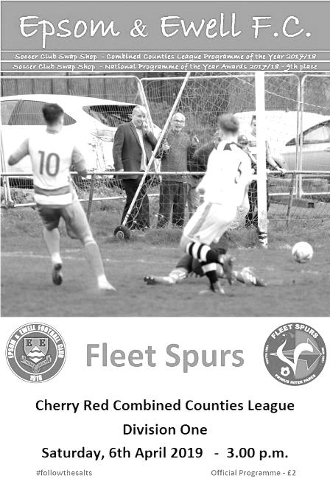
Salts drop more points in uninspiring home draw

Our unbeaten home record of six months dating back to 6th October remains intact, but only just as a hard working Fleet Spurs, fighting for their lives at the wrong end of the table came to High Road and created almost all of the good football today and will be wondering how they only left with the one point.

In truth, the main reason is because of an excellent display from our centre-halves and keeper. Scott Murphy and Lloyd Connelly blocked almost everything that came at them and everything else apart from a close range equaliser was denied by Josh Woodcock behind them. Elsewhere, a number of players really didn't perform with the only other player worthy of a positive mention being young Jake Robinson who impressed as a second half substitute.

It is also worth pointing out that the match nearly didn't start at all as we were let down by the non-appearance of an Assistant, who had let the referee know but not our club. This left Pete Beddoe frantically trying to get a replacement at extremely short notice and we were fortunate that one of our squad, Sam Eastgate, volunteered for the job. Clearly the league need to look into this non-appearance that nearly cost everyone involved a lot of money on a wasted journey and rearrangement.

We were nearly on the receiving end of a wonder goal in the third minute when Adam Bellmaine's powerful volley from an angle came back off our crossbar but we survived. The visitors then put a header just wide and when Mark O'Reilly was put through by a nice pass, Woodcock was there to block the shot with his legs for a corner that was only half cleared and a low shot was well held by our keeper. All this in the opening seven minutes!

We just hadn't got going and Murphy's only error of the day as far as I could see, came a minute later when he tried a back header to Woodcock but got the contact all wrong and sent the ball up in the air. Woodcock had to jump for the ball and headed the ball away but their striker retrieved it first. Luckily Connelly was well positioned on the line to block the goalbound shot.

The storm subsided for a while but a ball over the top to Bellmaine in the 18th minute left him through on goal although fortunately he was a little wide and his shot to the near post was well blocked by the well-positioned Woodcock. We finally mustered an attack a minute later when a clever pass from Elliott Thompson inside the full back to Bobby Bennett resulted in a corner after his cross was blocked, but it came to nothing. Hakim Griffiths then went down in the box but the contact was minimal and no penalty was awarded, probably correctly. Griffiths was then a yard

high and wide with a powerful strike on goal from just inside the penalty area soon after this.

However, we were soon back on the defensive after some really poor defending let Fleet through again. Woodcock blocked the incoming shot but it wasn't cleared and the next shot was then blocked on the line by Murphy. Even then the ball remained in play and another goalbound shot was headed off the line and over the bar by Murphy once again!

We were struggling to create anything, particularly on the left where the right footed pair Louis Chin and Jordan Gallagher were making little headway. As a result it will come as little surprise to read that our goal, completely against the run of play in the 40th minute, came from the right and a throw on was collected by Griffiths who held off his man, turned and let fly from the corner of the penalty area with a scorching left footed strike that took a slight deflection on the way to the top corner. Michael Cadle in the Fleet goal then had his first work of the day in picking the ball out of his net.

Griffiths saw another low shot deflected wide just before the half time break, but it must be said we had caused the opposition very little trouble to this point and we were extremely fortunate to be ahead at this stage. The second half was more even but with very little to write about at first. Thompson picked up a booking for his annoyance with the non-award of a free kick after he had been impeded and it was his last action as Robinson came on in his place almost immediately. He was probably right to be aggrieved as far less contact had been punished earlier, but there are too many dissent bookings being earned right now and it should be pointed out for the benefit of our supporters that club policy dictates a player gets fined double the cost of a booking in these circumstances i.e. they pay £20.

Rob Hendry was next to have a try after Griffiths had set up Bennett fortuitously for a pass with a bit of a slice, but his shot was blocked for a corner. This was followed by a scuffle between Bellmaine and Ryan Sullivan which earned them both a yellow card before Robinson shot wide of the Fleet goal in a rare attack. We'd have been fairly happy to this point as the game was looking like it would finish at 1-0 but there is a reason we haven't kept a clean sheet since 29th December and in the 71st minute the visitors had an extra man over on the left flank and the ball was fed in for an easy equaliser giving Woodcock no chance from close range.

The match got a little more stretched in the final stages. Connelly headed a Gallagher free kick at goal where Cadle made the easy save and Gallagher then set up Bennett but his cross to the unmarked Billy Carney was blocked before it reached our substitute. In the final moments of the game though, the visitors almost stole the points with two attempts, the first of which Woodcock made a low save to deny, while the second in the 96th minute came back off our crossbar again.

In recent matches we have bemoaned the state of the pitch and the standard of refereeing, but could have no complaints with either today as the Chipstead pitch was in great condition and the referee was only slightly fussy at times. Sometimes we have to look at our own performances and comparing this to Wednesday's fine showing was like chalk and cheese. To be fair to our visitors, they played well and the point almost certainly guarantees them safety from a match where, if I'm honest, they needed them more than we did.

Epsom and Ewell: Josh Woodcock, Adam Heagney, Louis Chin, Ryan Sullivan,
Lloyd Connelly, Elliott Thompson, Bobby Bennett, Scott Murphy, ©
Rob Hendry, Hakim Griffiths, Jordan Gallagher

Subs: Jake Robinson for Thompson (58), Ben Chick for Hendry (73),
Billy Carney for Griffiths (78)

From behind the goal
Bedfont & Feltham 4-6 Epsom & Ewell
Combined Counties League - Division One - Saturday 13th April 2019

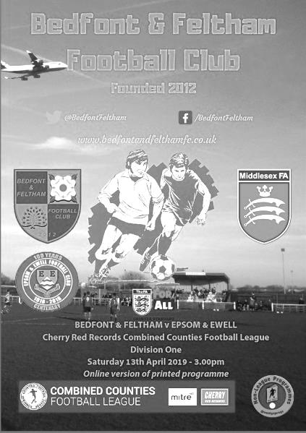
Hakim the star as Salts harvest more goals at the Orchard

Back in August 2016 we visited Bedfont & Feltham for an extremely memorable league match, where we trailed 2-0 at the half before winning by the improbable score of 9-2. Fast forward nearly three years and whilst we have had a number of subsequent visits to the venue, this was the next league instalment in the series between the teams, and it will remain almost as unforgettable as the previous match was, as we secured our first 6-4 win since 7th October 1961 when we defeated Dorking at the old Meadowbank in a Corinthian League match! It was only the fourth time in history that we had won by this scoreline and was the first time we had been involved in a ten goal match since the aforementioned 9-2 victory!

Going into this game it was hard to know what would happen. Both teams had produced brilliant showings this season, but had ultimately fallen away from the league title battle in recent weeks. It's fair to say that if nothing else, goals were expected, especially after the first encounter of the season had finished 4-4 back in December at High Road and so it proved, with both teams far too hot to handle going forward on a bobbly, end of season playing surface that was clearly difficult to defend on.

Back in 1961 our 6-4 win, the only one we had previously achieved away from home, was headlined by four goals from Jim Punter and history repeated itself in this match as Hakim Griffiths scored four times, varying in difficulty from the routine, to the brilliant, to the downright outrageous, although if it were not for a pair of injury time goals from Scott Murphy and Jordan Gallagher, Griffiths would have become only the second player in club history after Player / Manager Tony Williams in 1966 to have scored four times, yet not finished on the winning side, as this match was precariously balanced at 4-4 with moments remaining, despite having blown a two goal lead on two occasions. He also became just the second player this Century after Daryl Cooper-Smith to score four times in a match for us, with our former striker putting four past Worcester Park in a 6-3 League Cup win in December 2016.

As with any see-saw type of match, of which this was definitely one, there were a number of twists and turns and the first came in the second minute when Captain Scott Murphy took his eye off the ball, which then took a nasty bounce and enabled the home side's striker Michael Capon, the most dangerous striker in this league with over forty goals to his credit already, a clear run on goal from thirty yards out, but Josh Woodcock did brilliantly to stand up and deny him with the loose ball being cleared to safety. It is important, especially in a match with so many goals, to highlight two very important saves from our keeper; this one and another at the end of the match when we nearly went 4-5 down. For the opposition David Windmill also made a superb save in the opening ten minutes as Bobby Bennett broke through on the right and his shot across goal was superbly tipped wide for a corner as it headed for the bottom corner.

There were a number of incidents throughout this match, with only so much room to list as many as I can. However, it was apparent that we were getting on top of the home side and we took the lead in the 26th minute when Griffiths played a reverse pass to Gallagher on the right wing and he returned the ball in low for Griffiths to bury into the bottom corner from six yards in much the same way that he used to feed Cooper-Smith two seasons previously. Nine minutes later it was 2-0 as an Adam Heagney corner was flicked on by Lloyd Connelly and was met at the far post about twelve yards out by Rob Hendry who volleyed the ball back towards goal. It

wasn't his cleanest strike but it reached Griffiths inside the six yard box and he audaciously back flicked the ball into the net with his left foot. It was the sort of goal that we used to see from another former striker Robbie Burns and it must be said that Griffiths has the same quick feet that Burns possessed.

Despite all this good work we then shot ourselves in both feet just before half time. A long ball was allowed through and the early substitute Farhad Mahboudi was onto it in a flash. Woodcock drove him wide, but the shot still came in which Heagney was unable to clear. From where I was, it looked as though the ball had been forced in by a striker but it has since been confirmed to me that it was an own goal. Unfortunately our recent habit of conceding in clusters surfaced again and we at first got lucky when a poor back pass was intercepted, but we were unable to clear the danger and a deep ball back in to the far post was met by the unmarked Capon who converted a chance far more difficult than the one he had spurned at the start of the match with a neat side footed volley!

At 2-2 I felt that there was still a positive to take which was that we had been the better side for much of the match, so it was just a matter of putting our stamp back on proceedings again and we came out like a train with one humorous episode occurring when former Epsom old boy Steve Betancourt sliced the ball almost over his own bar for a corner while attempting his clearance, accompanied by much laughter from our players and a couple of his own teammates! Minutes later a Hendry free kick was glanced just over the bar from Reisse Griffin and in the 52nd minute Griffiths fed the excellent Jake Robinson who rounded the keeper only to see his shot cleared off the goal line by Billy Roach at the very last moment. This was a pity as Robinson had an excellent match and thoroughly deserved a goal that would have been his first for us. That will surely come soon.

Despite our hard work we were still not in front, and thoughts drifted to whether we would be made to pay for these missed chances, but in the 55th minute Griffiths had other ideas, controlling the ball well before sending the ball screaming past the motionless Windmill into the far corner of the net from 25 yards. It was similar to his strike against Fleet Spurs the previous week, except this one came from his right foot and was arguably even more powerful. Two minutes later a clever pass inside the defender enabled him to run through at goal and although being slightly wide, he drilled the ball back across the keeper into the far corner to register his and our fourth goal.

From this point we seemed to sit back a little and they fired a warning shot just above our cross bar on the hour before reducing the arrears in the 65th minute with a goal of simplicity, a simple right wing run and low ball in for Capon to pounce upon and score his second goal of the match from close range, giving Woodcock no chance. In response Windmill was bravely out to block Griffiths as he ran on to a Ryan Sullivan pass and Hendry picked up an unnecessary yellow card for almost ripping the shorts off an opponent. Of course 4-3 is a far more precarious lead than even 1-0 and with the memory of December's 4-4 draw fresh in the mind it was almost predictable that Bedfont & Feltham would equalise and one of our defenders should now be wearing the Hawaiian shirt after failing to mark Betancourt who scored his first goal for his new club with an unmarked near post header from a corner in the 87th minute.

But there was still more drama to come as another right wing cross came in and was met at the far post with a low strike but Woodcock was out to block superbly. We cleared the subsequent corner and at the other end Gallagher hooked the ball inches beyond the far post with a chance of his own after being fed by Griffiths in the 90th minute. However, he would then get another chance a minute later when he beat Charlie Dunckley who lunged in a bit and brought him down. It seemed an eternity before the referee made his decision but finally the penalty was given. Without regular taker Bennett who had been replaced due to a tight hamstring, Scott Murphy stepped up and blasted the ball into the roof of the net in the 92nd minute. Then two minutes later Gallagher got through again. He was forced a little wide and I was shouting for him to go to the corner flag. Maybe the defender heard me and was expecting the same at which point Gallagher slid the ball past him and slotted it from ten yards across Windmill into the far corner from a narrow angle to complete the scoring.

Looking back at this bizarre match, it is notable that five matches against Bedfont & Feltham have now produced 37 goals between the teams. Whilst serious questions could be asked about some of the defending on both sides, these two teams will definitely be meeting each other again next season, so it might be worth making a note in the diary for when those two fixtures are scheduled!

Epsom and Ewell: Josh Woodcock, Adam Heagney, Reisse Griffin, Ryan Sullivan, Lloyd Connelly, Jake Robinson, Bobby Bennett, Scott Murphy ©, Hakim Griffiths, Jordan Gallagher, Rob Hendry

Subs: Ben Chick for Bennett (66), Louis Chin for Hendry (76), Todd Murphy for Griffiths (93)

From behind the goal
Epsom & Ewell 0-2 FC Deportivo Galicia
Combined Counties League - Division One - Tuesday 16th April 2019

Abject performance leaves top six finish in jeopardy

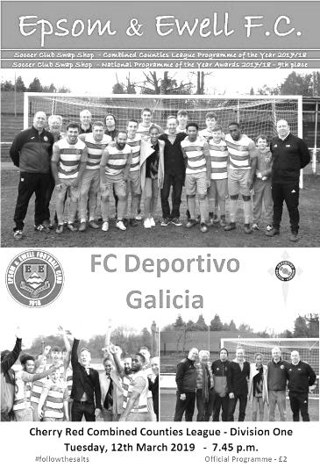
Our unbeaten home record, dating back to 6th October was surrendered with a whimper on Tuesday evening as a virtually full strength team failed to score at home in a league match for the first time this season against a visiting opposition that had suffered motorway troubles and only arrived half an hour before the scheduled kick off, which was delayed slightly.

With exception of a bright and breezy opening twenty minutes, once we had conceded to the hard working and fully committed Galicians we simply ran out of ideas, looked predictable and provided absolutely no quality from either flank, be it in open play or from corners, despite having cruised past the same opponents on two previous occasions this season already.

Maybe that was the problem. There have been too many occasions this season where we have just thought that we only have to turn up to claim the points and Reisse Griffin apart, who always gives everything and more in every match he plays, we failed to match our opponents physically or find a way around the lack of space that our opponents restricted us to, instead going sideways for much of the match with possession eventually breaking down. Looking at the teams at the bottom of the league this season, we have scraped past Cove twice after trailing on three occasions, while we were lucky to defeat Fleet Spurs in our first match, and drew the second. We have also drawn and lost to Kensington Borough, while we lost at Eversley & California and now this. A full season on from our relegation, our players don't appear to have grasped that what our opponents may lack in technical qualities, they more than make up for in effort; an area where we are sorely lacking at times like this.

It could be argued that this was our worst display of the season. At least a Kensington Borough we were woefully short of players and suffered an early sending off. Here we had no such excuses. With exception of the injured Bobby Bennett who was replaced by Ben Chick in the only change from Saturday's goal fest at Bedfont & Feltham we had a full side to choose from and we also played the final forty minutes of the match against ten men after Leandro Amaro's rather unnecessary sending off.

However, Amaro had already put his mark on the match back in the 26th minute, when a corner was half cleared and he smashed the ball back into the net with a dipping strike from outside the penalty area. Josh Woodcock might feel that he could have kept it out and there was certainly a surprise amongst the visitors when they saw that the shot had actually gone in, but it was the turning point for us after an opening period which had seen us dominate possession but with a header from Rob Hendry from a deep corner being directed wide at

full stretch and a Jake Robinson left footed volley that was too high for the target, being our only actual threats on goal.

We were being caught offside frequently, which was proving frustrating as the game wore on and any momentum we were trying to build kept being stopped. As we approached the half time whistle we put together one decent move as Lloyd Connelly sent a deep ball in where Adam Heagney sent it across goal and Hakim Griffiths met it with a strike on goal, but unlike his four on Saturday against Bedfont & Feltham, this one was easy for debut keeper Dani Diaz who made the easy save, as he did in first half injury time when he collected Hendry's long range strike.

We started the second half with more impetus. Jordan Gallagher, who had been fairly invisible playing in the centre behind Griffiths, swapped places with Hendry and began to threaten on the left wing and he found Robinson just inside the box with a low ball in, but somehow his shot was deflected over the bar by either a defender's or the keeper's boot for a corner. From that corner Griffin was inches over with a header.

The pressure was beginning to build as our work rate increased for a while and Amaro, who had been booked as early as the seventh minute, clattered into Gallagher in the corner rather stupidly just five minutes into the second half, giving the referee no choice but to produce a second yellow card and leave the visitors down to ten men, with Griffin again unlucky to keep his header down from the subsequent Gallagher free kick.

Billy Carney replaced Griffiths but we were still struggling to produce anything of quality and some poor decision making began to creep in with players trying to do too much. Gallagher twisted and turned his man before firing into the side netting with players waiting across the goal while passes were being missed all over the place whenever we got into the final third of the pitch. Liam Roberts replaced Ben Chick on the right wing on the hour, but insult was added to injury when we conceded a second goal four minutes later after a missed challenge let in Bruno Cromes, working hard up front on his own following the sending off and he held a challenge off before firing low past Woodcock from close range. They then nearly scored a third with a free kick that dipped over the bar from thirty yards and grazed the netting.

Elliott Thompson came on for Connelly in the 70th minute as we reverted to a back three in an attempt to change things around, but it is an indication of how poor the remaining twenty minutes were that there is not a single entry in my notebook from that point onwards as the game petered out and the visitors took home the points, having clearly wanted them more.

There is a rumour going around that a top six place will guarantee Step Six teams a place in next season's F.A. Cup. I'm not convinced it is true, but our players put in a performance against FC Deportivo Galicia that made you think they didn't want to enter next year's competition at all! Based on our Manager's comments after the game, many of the players will get that wish.

Epsom and Ewell: Josh Woodcock, Adam Heagney, Reisse Griffin, Ryan Sullivan,
Lloyd Connelly, Jake Robinson, Ben Chick, Scott Murphy ©, Hakim Griffiths,
Jordan Gallagher, Rob Hendry

Subs: Billy Carney for Griffiths (55), Liam Roberts for Chick (61),
Elliott Thompson for Connelly (70)

From the back of the main stand
Epsom & Ewell 1-3 Sandhurst Town
Combined Counties League - Division One - Saturday 20th April 2019
Report by George Holland

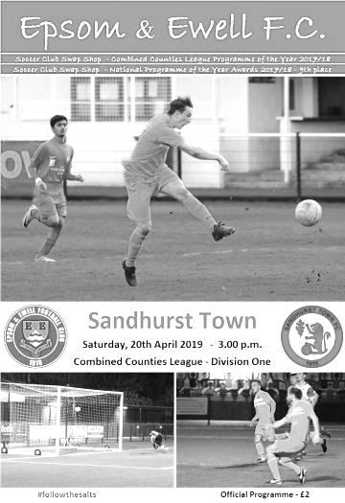
Salts are outmuscled with military precision by Sandhurst Town

The Salts continued their poor form from Tuesday night's 2-0 home defeat to FC Deportivo Galicia with this 3-1 defeat to Sandhurst Town, who were better in every aspect of the match.

In terms of the starting line-up Rob Hendry and Ryan Sullivan were non-starters while Ben Chick reverted to the bench. In their place came fit again Bobby Bennett, Liam Roberts and Louis Chin.

The Fizzers out-played, out-fought, out-thought and out-muscled the Salts, both as a team and individually. Particularly targeting Liam Roberts with some heavy, robust tackles which would have earned some red cards, instead of yellow cards, with much stronger and firm officiating.

Roberts did however, earn himself a booking for dissent, when disagreeing with the Referee over Sandhurst's tactics, and falling over theatrically a few times when fouled. A section of the Fizzers' fans were also intimidating Roberts at every opportunity.

In a very one sided first half, the Salts rarely got their game together, going 3-0 down by half time with a slight improvement in the 2nd half. By then the Fizzers were out of sight.

On a very hot and sunny day, the conditions were perfect for football. In the early exchanges, the Salts first real chance came on 11 minutes when the first of many fouls Liam Roberts saw Fizzers' Mitchell Cooper given a yellow card. The resulting free kick was blasted well over the bar by Scott Murphy.

The Fizzers took control of the match on 20 minutes when the ball was played into the box, the Salts defence failed to clear the danger, and Callum Samuel-Harman slotted home into the corner past Josh Woodcock for a 1-0 lead.

Another shocking foul on Roberts on 27 minutes only resulted in a yellow card for Luke Cox, much to the surprise of those around me, including a retired Referee, when we

were fully expecting a red card for an elbow in the face. Again the free kick was wasted.

Bobby Bennett then shot well wide on 29 minutes, before the Fizzers made it 2-0 on 30 minutes through Patrick Gardener. A cross came in from the right saw an unmarked Gardener easily outjump the advancing Woodcock, and head the ball into a totally unguarded and empty net, with the Salts defence statuesque.

Both sides had further chances before Roberts earned his booking for dissent on 35 minutes. Only three minutes later the Salts had two bites of the cherry from two corners, resulting in Scott Murphy's shot being headed off the line and cleared away.

However, it got worse on 40 minutes when the score became 3-0 to the Fizzers. Patrick Gardener latched onto a long, high, bouncing through ball. He outpaced the defenders and lobbed his shot over Woodcock into the back of the net for his 2nd and Fizzers' 3rd goal.

Both teams had a further chance each before the whistle went for the break at 0-3.

10 minutes into the 2nd half Salts' Jake Robinson headed a shot off the line when it looked destined for the top corner.

Salts came more into it on the hour mark when Jordan Gallagher won the ball out on the left, he fed Ben Chick whose shot went just past the frame of the upright.

Woodcock made two great saves when one on one a minute later to prevent a fourth goal going in.

Reisse Griffin had an effort saved on 62 minutes, before Gallagher reduced the arrears to 3-0 four minutes later. He took a pass, unmarked, and strode forward before shooting left footed past keeper Matthew Watson into the far corner. Fizzers' defenders were appealing for offside to no avail.

On 68 minutes Roberts was diplomatically substituted, so on came Todd Murphy.

A poorly wasted Salts corner on 72 minutes was cleared, the counter attack saw a low shot well saved by Woodcock, and the danger was cleared.

Both sides then created and wasted further chances. Bobby Bennett's deep cross from the right did produce a fingertip save from Matthew Watson on 88 minutes. The resulting corner came to nothing. With the clock now going over into injury time, the match fizzled out at 3-1 to the Fizzers.

The Salts have learnt a harsh lesson from this defeat. They will need to be more physical to compete in this league if they want to win anything next season.

Epsom and Ewell: Josh Woodcock, Louis Chin, Reisse Griffin, Adam Heagney, Lloyd Connelly, Jake Robinson, Liam Roberts, Scott Murphy (c), Billy Carney, Bobby Bennett, Jordan Gallagher

Subs: Ben Chick for Billy Carney (57), Elliott Thompson for Louis Chin (66), Todd Murphy for Liam Roberts (68)

Previous Managers

In our final instalment of this series we look at a period covering our time in the Combined Counties League.

Lyndon Buckwell – 04/11/2006 – 13/09/2014
Glyn Mandeville – 20/09/2014 – 13/01/2018
Neil Grant – 16/01/2018 – 10/10/2018
Simon Funnell – 20/10/2018 – present

Lyndon Buckwell was appointed at a very difficult time for the club. We were near the foot of the table in our first season since transferring from the Isthmian League to the Combined Counties League and were still reeling from the tragic and sudden loss of our Secretary Dave Wilson in September 2006.

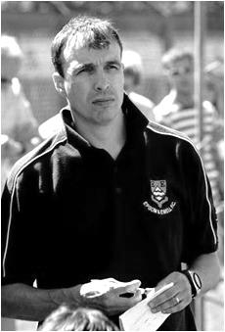
Buckwell was of course a former player and had also gone on to represent Kingstonian and Corinthian Casuals following our relegation to the Isthmian League Division Three in 1991. He was in charge of Corinthian Casuals Reserves with another Epsom “old boy” Tony Coombe as his Assistant and our club chose them, following open interviews, to turn our fortunes around.

Their opening match was a key one. We were adrift in the bottom two but away to the club immediately above us, Bookham. It was important that we didn’t get cut further from the pack but following an early error by the Bookham keeper that left Adam Pero with a roll in, we cruised to a 3-0 win and three days later defeated Cobham by the same score at Merland Rise in a match that provided a debut for future Captain Jamie Hatfield. Although the season was still a tough one with a final placing of 17th out of 22 there were lots of positive signs.

In 2007/08 we started to see some new faces. In goal came Paul Borg, an excellent keeper from Leatherhead, while up front two new strikers were also joining us by the names of Kyle Hough and Robbie Burns. Between them they would rack up 328 goals for us over the next decade and both opened their account on the same day; the Bank Holiday August 2-1 victory over Horley Town at Merland Rise. That season we finished in a far more respectable 10th place but the following season 2008/09 we reached a twenty year high of fourth place. This had the added benefit of providing us with a bye to the First Round Proper of the F.A. Vase for 2009/10 where wins over Farnborough North End, Moneyfields and famously Wellington AFC down in deepest Somerset sent us through to the last 32 where we were narrowly defeated 3-2 by Long Buckby in Northamptonshire. Unfortunately we were only able to finish fifth that season after actually topping the league at the end of September.

Also that season we left Merland Rise after seventeen years ground sharing and moved to Merstham for two seasons. The facilities were much better as was the playing surface but in a disappointing season, despite promises from Buckwell that we’d be able to get better players, we finished tenth again and the only highlight was an exemption in the Vase that gave us a home tie and a 4-0 win over Bracknell Town before being edged out 2-1 on a very cold night by Vase favourites St Neots Town after we had led early in the match. A fourteenth placed finish followed and we decamped to Chipstead for 2012/13 in the hope that improvements would follow.

And they did! 2012/13 contained some fantastic memories. Despite a slow start in the league that

would ultimately cost us, a Dale Marvell rocket at Camberley Town on 24th November 2012 would mark the start of a club record twelve straight victories in the League added to two wins in the League Cup, knocking cup holders Guernsey out 2-0 on a cold January evening before smashing AFC Croydon Athletic 6-2 at the Croydon Arena.

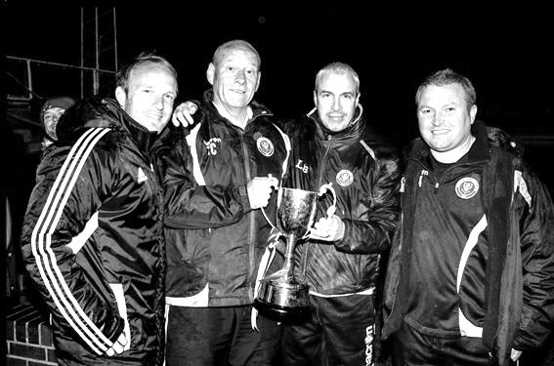
The winning run had a few close calls, not least when Burns netted an 88th minute winner for ten man Epsom at Raynes Park Vale, but finally ended in February against Windsor with us at the top of the table. However, as league form began to fall away, leading to another fifth place finish, we then defeated Champions elect Egham Town 1-0 on their own pitch in the League Cup Semi-Final, with a Mark Jarman goal, despite facing Borg in the Egham goal. Jarman was then sent off and would miss the Final, but we were superb that day as goals from Hough, Burns and a screamer from full back Sam Currie enabled Hatfield to lift the Cup as South Park were defeated 3-0 at Farnborough’s Cherrywood Road ground; our first trophy since the Surrey Senior Cup way back in 1981!

From left to right Russell Banyard, Tony Coombe, Lyndon Buckwell and Glyn Mandeville

In 2013/14 we started off like a train with eight straight wins, but gradually were overhauled by eventual Champions South Park and by season’s end Camberley Town too. Things had changed off the pitch too as Chairman Tony Jeffcoate had suffered a stroke at the start of the season and this meant that Pete Beddoe and Steve Dyke had taken a better look at the finances than had been the case in recent years.

The playing budget would have to be cut for 2014/15 and whether this was the reason, or whether the travel from his new home in Pulborough was the main issue, Buckwell chose to resign in the September of 2014, just after we had been knocked out of the F.A. Cup by Croydon. By now Mandeville had taken on the Assistant Manager role with Coombe increasingly side-lined and it made total sense to the Committee for the reins to be passed to the popular choice. It was a smart move and Mandeville steadied the ship that season, recovering the position so we finished seventh. New players like Matt Ferdinando came in almost immediately and they would be joined

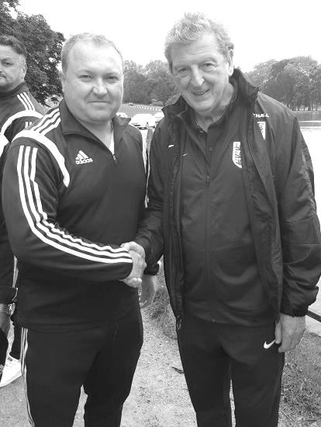
by Agi Panayioutou and Daryl Cooper-Smith in the January. Many new players had started the 2014/15 season as a result of the changes with Dan Dean, Matt Farrell, Matt Tanton, James Taylor and keeper Michael Eacott all strengthening the team. Also, Glyn had become the first non-Epsom player to take charge of the club since Peter Spittles way back in 1973, but that was corrected as he came on as a substitute in a 5-1 win at Frimley Green in May 2015.

By 2015/16 things were getting better still as we finished in fourth place. The club were then invited to Chantilly in the summer of 2016 where they represented the town a lot better than our country did in the Euros that were taking place at the same time!

Left: Glyn meets Roy Hodgson in Chantilly

The players stayed together for the following season with exception of Kyle Hough who departed for Horley and we started the season in an explosive manner as we trailed Bedfont & Feltham 2-0 at half time only to rattle in nine goals in the second half with Cooper-Smith and Farrell both scoring hat tricks. However, by the end of the season fourth place was the limit of our achievements once again, although we did reach the League Cup Final once again, being well beaten 4-1 by Westfield in the Final at Stag Meadow, home of Windsor FC. (see picture of the teams being presented below)


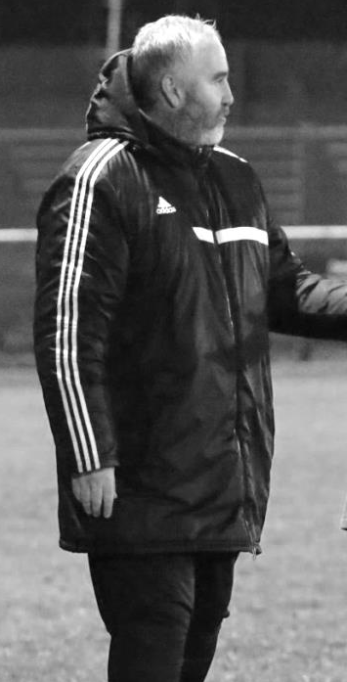
Then disaster occurred with a number of our players leaving for local rivals Sutton Common Rovers in the summer of 2017. This knocked the heart out of our Centenary season before it had begun and clearly affected Mandeville personally. Coach Matt Smith also departed the club and we spent much of 2017/18 at the bottom of the table. The club acted to bring in a new Coach in Neil Grant (pictured below) from the Leatherhead Academy in October of 2018 and he brought in a number of new players to give us a chance of survival. By the end of December though things weren’t improving enough and we were stuck on seven points. With a big match against Godalming Town coming up Glyn advised that he would be resigning after the match which ironically we won 2-1 with debut goals from Kyen Nicholas and Marlon Pinder, both Grant signings.

Grant was offered the position from that point with a brief to see what he could do in the time remaining, despite all parties realising, if not publicly admitting that it was probably far too late. As it was we overhauled Farnham Town to climb off the bottom by the end of the season and showed potential for the new term ahead with a 4-0 win at North Greenford United and there were high hopes for an automatic return to Step Five despite the relegation.

Alas it was not to be. Grant made the mistake of guaranteeing promotion at the club Annual General Meeting. It was nice to hear at the time, but it placed a huge burden of expectation on him and although we started well with two league wins and an F.A. Cup win at Langney Wanderers, inconsistencies started to affect the team.

Club Captain Alex McKay left the club, mostly to concentrate upon his refereeing commitments, and he was replaced by Scott Murphy, a former player from the early days of Buckwell’s reign, but we really needed to be Champions to be certain of promotion this season and as defeats began to occur more frequently, rumours about issues in the dressing room started to appear.

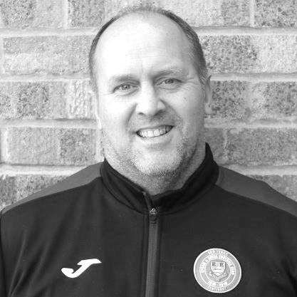
The matter came to a head in October when an awkward working relationship with the Committee broke down and coupled with a pair of identical losses to Sheerwater and British Airways, it was decided that it was time for our Manager to fly, with his replacement being the current man in charge, Simon Funnell who moved up from the Assistant role, but with a wealth of experience as a player at Brighton & Hove Albion and as a Manager at East Grinstead Town, Shoreham and Chipstead.

Despite an excellent start, Simon was unable to turn things around as we tailed off a little towards the end of the season. However, Simon will be given every opportunity to earn promotion next season and we of course wish him well.

I hope you have enjoyed this series about our previous Managers. Feedback is welcome, as long as it is positive

Centre page for results

Centre page for results



Match and Ball Sponsorships – 2018/19
Opponent | Date | Match Sponsor | Ball Sponsor
Chessington & Hook Utd | 21/08/18 | Club President - Stella Lamont
Beckenham Town (FAC) | 28/08/18 | Building Shop Ltd
Cove | 08/09/18 | EEFC Management Committee
Tooting Bec | 15/09/18 | Building Shop Ltd
Bagshot (LC) | 25/09/18
Sheerwater | 06/10/18 | Paul Merritt
Knaphill U23  (Surrey Premier Cup) | 23/10/18 | Jack Jarman
Frimley Green | 03/11/18 | Our Chairman’s Grandchildren – George, Joseph, Ezara and Inaya
Sandhurst Town (LD1C) | 06/11/18 | Richard Lambert
Kensington Borough | 17/11/18 | Jeff & Arnold Pye
Dorkinian (SPC) | 20/11/18
Dorking Wanderers Res | 27/11/18
Godalming Town | 01/12/18 | John Bonner
Bedfont & Feltham | 08/12/18
Eversley & California | 29/12/18
Ash United | 12/01/19 | Gary and Gemma Jarman
Bagshot | 19/01/19 | Steve and Geoff Dyke
Godalming Town (LC) | 12/02/19
British Airways | 16/02/19 | Pete Lumm
British Airways | 16/02/19 | Stephen Charnley
Fleet Spurs | 06/04/19 | Steve and Geoff Dyke
FC Deportivo Galicia | 16/04/19 | Alex McKay (senior)
Sandhurst Town | 20/04/19 | Club President - Stella Lamont
Farnham Town | 27/04/19 | In memory of Chris Henry R.I.P.
Match sponsorship costs just £60.00!

Sponsorship includes:

Admission, programmes and hospitality for three people.

A full page advert in the programme and mascot for the day (if required).

If you are interested, just speak to a Committee Member,
or drop me an email at: richard.c.lambert@gmail.com

Player Sponsorship
Here is the latest list for 2018/19, with photos showing all of our players and Management that are available for sponsorship.

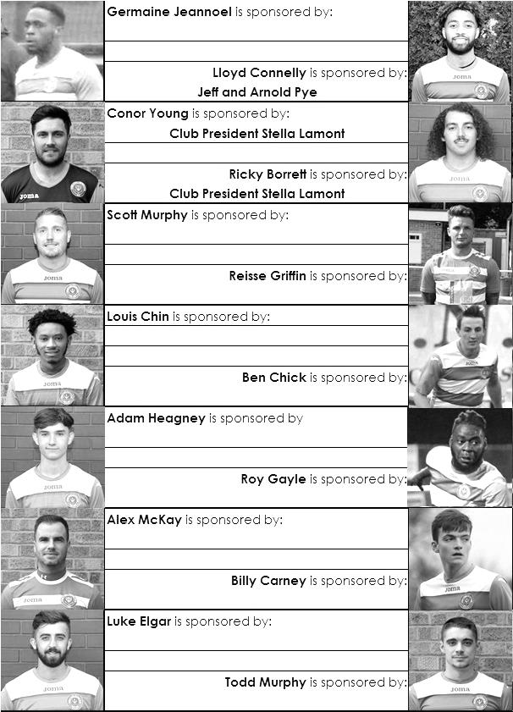

Sponsorship costs just £40 and it is easy to do. Just select a player who has not been previously sponsored and let a Committee Member know that you would like to sponsor them. Beware though. Until we have received the money it is possible for someone to jump in front of you, so don’t delay, sponsor today!

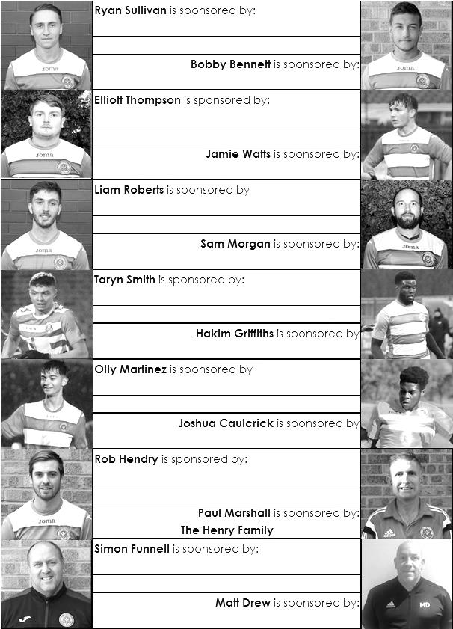

90 Years ago – 1928/29
After the progress of recent years, the club had high hopes of winning the London League again and gaining promotion to the Athenian League, but it was not to be. Maybe it was too much to expect as the close season saw considerable upheaval. In addition to the tragic loss of their President, Chairman Hugh Bradley and Treasurer S.R. Prett also resigned. A well-known local figure in Sir Arthur Glyn was appointed as President, while A.P.Baker took over the financial duties. The most relevant change was the appointment of Harry “Charles” Pettett as Chairman of the club. A surveyor by trade, Charlie was also well-known in local whist drive circles, where he was a regular “M.C.”. His name is one of the most important in the entire Epsom football story.

Despite last season’s fine record, extra travelling costs incurred in the London League meant that the club lost £52.18s. This did not go down well at a very lengthy Annual General Meeting this year, and the accounts were very nearly not accepted by the membership. After plenty of discussion they were carried by twenty-three to seven, but only after Hugh Bradley explained that the meeting would have to be adjourned otherwise.

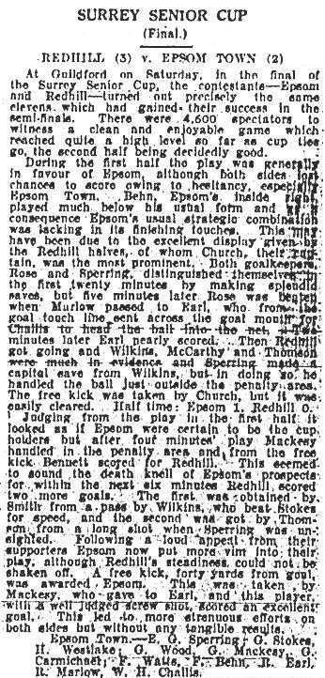
Back on the field there were very few changes. The first match of the season saw the traditional match at home to the rest of the London League, which we won 3-0. If they thought it would be easy to repeat as Champions after this result, then they were in for a shock. The league business got under way the following Saturday with a nine goal thriller against Bostall Heath. Epsom had been leading 3-1 at one point, but they needed four goals from Reg Marlow to edge the game 5-4. Millwall United then took a point from them before Epsom Town travelled to Cray Wanderers, where they were defeated 5-3. If this was not enough, the following Wednesday they suffered the embarrassment of a 4-2 home defeat by Lloyds Bank in the Final of the East Surrey Hospital Cup, which had been held over from the previous season. Tooting Town then scored a last minute penalty at Sandy Lane to end the F.A.Cup interest for another season.

The Amateur Cup run was little better. A Behn hat-trick saw a 4-3 win over Aquarius, but 2,500 people saw them lose 2-3 at Gander Green Lane to local rivals Sutton United. The real story here was a protest submitted by Epsom Town over the eligibility of two of the home players, Okin and White, playing Sunday football. In those more religious days, playing football on God’s day of rest was a serious matter, and was frowned upon by the powers that be. As it turned out though, the protest was thrown out by the F.A. on the basis of a lack of evidence, and they also charged the club two guineas for the appeal costs. However, the matter did not go away, and Sutton’s Amateur Cup run would eventually be terminated after further appeals in later rounds, with the players concerned being harshly banned for life.

A 2-1 defeat at Redhill in the Surrey Charity Shield left Epsom Town deflated, and league results were erratic. The Blues won 1-0 at Chelmsford, only to lose the return at West Street two weeks later. They then defeated Grays Athletic 3-2, and gained revenge with a 4-2 win over Cray Wanderers, only to drop points in Belvedere with a 1-1 draw against Callender Athletic. Home league wins over Tooting and Callender were registered in December, before a Christmas double header with Finchley ended in one home win apiece.

Attendances at this time were around the 1,000 mark for a London League game, with the figures increasing for local matchups or cup ties, and the club announced that they had persuaded the railway authorities to issue return tickets to Leatherhead and Ashtead at the price of a single if they attended a match at Epsom! The next match was in the Surrey Senior Cup, where Epsom Town had received an exemption, and the signs were good as the draw had given them a home tie with the Westminster Bank long before they became the Nat West Bank that we know today. They were a decent team, and had plenty of support singing their regular refrain “Swing it West”, but even so it was a surprise when the tie finished goalless, despite extra time of twenty minutes each way. The replay was also at West Street, as the Bank conceded home advantage, and we came through 5-1.

The Casuals were next up in the Quarter-Final of the Surrey Senior Cup. They had conceded ground advantage, as they ground shared in those days, and their pitch was double booked. Their greater experience saw them leading at half-time, although goals from G.Carmichael (2), and Fred Behn ensured a 3-1 win for the home side. Almost in celebration they thumped Walthamstow Grange 6-0 in the league, but just when momentum was building, the largest league gate of the season saw over 2,500 expectant spectators disappointed with a 1-0 loss to local rivals and title chasers Mitcham Wanderers, although surely the result would have been different had full back G.Stokes not been injured after just five minutes. Westlake had missed a penalty and Challis had a perfectly reasonable goal disallowed as the ten men dominated, but there clearly wasn’t going to be a repeat title this year.

Fred Behn scored four goals as Carshalton Athletic were defeated 6-0, but results remained inconsistent, with two wins and two losses. It is possible, and entirely reasonable that the players had one eye on the biggest game in their history coming up. On 6th April, 5,000 spectators filled the Richmond Road ground in Kingston for the Surrey Senior Cup battle between Epsom Town and favourites Wimbledon. Watts came in for Hill on the right, while Carmichael took the injured Etheridge’s place at centre-half, and Earl was selected to play up front with Marlow, who had been filling Parr’s inside-left position in recent weeks. The papers stated that it was a gamble in recalling Earl for such an important game, but some gambles work, and an Earl header put the underdogs ahead at half-time. Although Wimbledon equalised in the second half they were “completely overwhelmed” in the last ten minutes, as Epsom Town scored three more, through Behn, Watts and Earl again to win the tie 4-1 and reach their first ever Surrey Senior Cup Final.

For the Semi-Final, the crowd of 5,000 raised a “gate” of £170 12s 6d, but by the time the Surrey County F.A. and the Kingstonian football club had taken their “expenses”, the two competing clubs received just £24 11s 8d each. The Final, which was originally due to be at Dulwich, where it surely would have attracted a bigger gate, was relocated to St Joseph’s Road, the home of Guildford City two weeks later, where 4,600 saw an unchanged eleven take on regular opponents in Redhill, who were making their third visit to the Final.

The debutants were the better side in the first half, and a Challis header after twenty-five minutes gave them a deserved half-time lead, but four minutes into the second half disaster struck, as a shot cannoned off Westlake and hit Mackesy on the arm. The referee awarded Redhill a penalty that was converted, and six minutes later Redhill were 3-1 up and in total control. While an Earl goal with twenty minutes left reduced the deficit, the equaliser would not come, despite Marlow hitting the post, and a free kick hitting the top of the crossbar, and Epsom Town were defeated 3-2 after being the better side for the majority of the match. Ironically it was argued in the local papers that Redhill shouldn’t have even been in the Final, as they had played Sutton United in an earlier round, but because of their Amateur Cup run, they had fielded a weakened side and allowed the Reds to progress! The papers said that an Epsom Town v Sutton United Final would have been much better, but it would be 55 years before we would find out that they were wrong!

Perhaps understandably, remaining performances were lacklustre, and two draws followed by two defeats left the club eleven points behind the new Champions Mitcham Wanderers, who continued the trend set last year by the Blues in winning the title in the last match of the season, on the ground of the previous Champions, winning 4-0 at West Street on the 4th May, and pipping Grays Athletic on goal average. Had goal difference been used as it is today, then Grays Athletic’s +55 would have surpassed Mitcham’s +50, but it was the better defensive record that was a more important factor when average was used, and Mitcham had conceded just twenty goals in their twenty-four matches.

Seasonal Summary
The 2018/19 season was a strange one in many ways as we found ourselves in Step Six football for the first time since the 1920s before we became a Senior club.

But there was no time to lick our relegation wounds as we needed to bounce back to Step Five as soon as possible. Pre-season results were fairly average and it came as a surprise therefore when our Manager Neil Grant guaranteed promotion at the club Annual General Meeting in July.

As we took this step into the relative unknown, it was hard to know what to expect. We knew a number of the teams of course, not least Farnham Town and Godalming Town who had come down with us, but a number of others like Frimley Green, Cove, Ash United, Sandhurst Town and of course local rivals Chessington & Hook United. We knew far less about Bagshot, Fleet Spurs, Sheerwater and AC London and had no clue about the standard of the promoted teams Tooting Bec and British Airways but the general, somewhat naïve concept that we’d be alright remained.

We had a number of new players, most notably Bobby Bennett and Steve Betancourt from Godalming Town, while in goal to cover Conor Young’s cricketing absence, former Youth team keeper Ricky Borrett went between the posts for most of our opening fixtures. In midfield new signing Ryan Sullivan was joined by the fit again Elliott Thompson, while up front we had Kieran Campbell, our former keeper from 2013/14 reinvented as a striker. We also had a new support team as Simon Funnell joined as Assistant Manager and Sam Morgan joined as Coach.

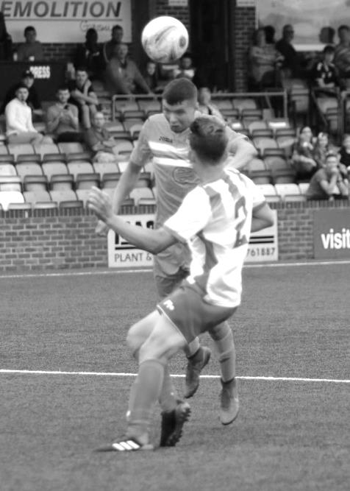
The season commenced on a blazing hot day at Sandhurst Town where we were boosted by the reappearance of Adam Heagney in our line-up after a spell at Guildford City. We had a poor record against the Fizzers historically, prior to their 2012 relegation and transfer to the Hellenic League but they were back this season and having been fourth in that league the previous season this looked like a tough opening encounter but we breezed through it, winning 2-0 and five wouldn’t have been unfair.

However, news was coming in up the road that Bedfont & Feltham had smashed Bagshot 11-0 and we knew that Bagshot were our next league opponents so it would be interesting to see how that match would unfold.

Before we could worry about that though we had to make a visit to Priory Park, home of Eastbourne Borough whose new tenants Langney Wanderers were our hosts for an F.A. Cup tie. A tough opening few minutes ensued but a near post Lloyd Connelly header kept the hosts at bay for a while. They did eventually equalise but in the final ten minutes they had a player sent off and we took advantage, Taryn Smith breaking through on goal and whilst his shot was blocked, the ball looped up off the keeper for him to head the ball into the vacant net and send us to Beckenham Town in the next round. (see picture left)

Smith’s finest spell for the club came in the next match at Bagshot, despite only coming on as a substitute twenty minutes from the end of the match as he scored a hat trick to break a nervy looking goalless draw that could have been worse if not for a superb save by Borrett just after Smith had joined the fray. It wasn’t eleven, but no one seriously thought that would happen again and Bagshot would survive quite comfortably by the end of the season despite their horror start.

Our perfect start was about to be dented by a regular adversary. Chessington & Hook United have only ever beaten us once at Chalky Lane, but we have lost a succession of home matches to them at Merland Rise, Moatside and of course High Road too. It didn’t help to lose Borrett to an early sending off when he had to come out of his area and handled the ball as early as the ninth minute but they continued to slice us apart and were 2-0 up at the break. Things were adjusted at half time but the damage was done even though we were the better side in the second period, reducing the arrears through Bennett and pushing for an equaliser, but it didn’t come and our rivals celebrated long and loud at the final whistle. Their time would come.

But first we had to negotiate the next rounds of the FA Cup and Vase within seven days. Beckenham Town had started unbeaten in the Southern Counties East League and of course were a division higher, but we led early with a superb low strike from Liam Roberts. We couldn’t hold on and found ourselves trailing before Roberts rescued things with a stunning strike into the top corner to force a replay. We had been the better side for the majority of the 2-2 draw but in the replay we were outclassed and it was only thanks to heroics from George Gill, an emergency replacement in goal to cover Borrett’s suspension that we took them to extra time where they won through 3-0. Below: Liam Roberts scores our second goal at Beckenham Town

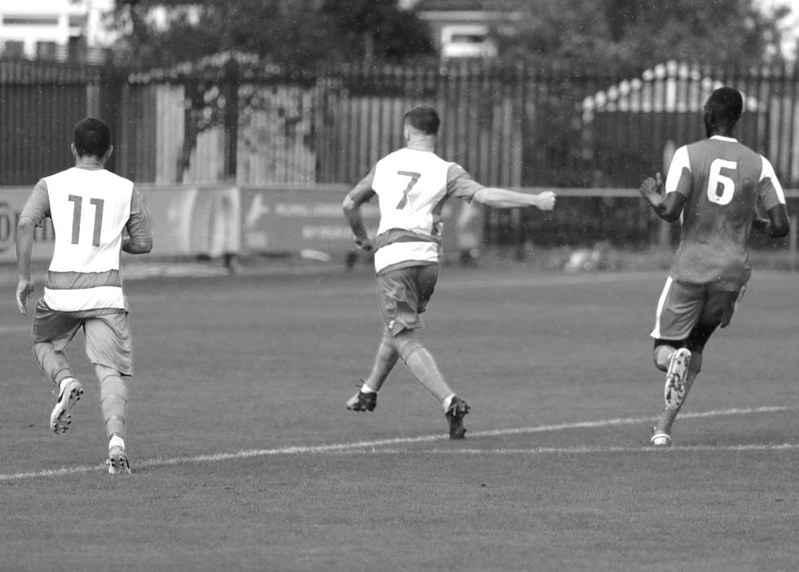
Things then got worse in a hurry against another Step Five team, Lingfield in the Vase on a Friday night at Whyteleafe, as their own pitch wasn’t available that early in the season. They tore us apart, winning 6-1 and the first questions about whether we were actually strong enough started to surface.

Those thoughts temporarily subsided as we made our way back to Whyteleafe five days later for a League match with AC London. A competitive match ensued but towards the end of each half, the home side imploded spectacularly and we scored three times in each half. They then had a player walk off the pitch near the end to provide a bizarre ending to proceedings.

Unfortunately we were already aware that they had been playing on borrowed time as they were appealing against expulsion from the league for previous misdemeanours. Their removal from the league table would eventually come in November, delayed by the process of a counter appeal from the club against the league. Classy! Some clubs would have removed this result from their records, but if someone was sent off in that match they would be suspended, so why shouldn’t their goals count? Particularly in this case for Bennett who scored a hat trick. He will always keep those goals in our records, even if we ultimately wouldn’t get the league points.

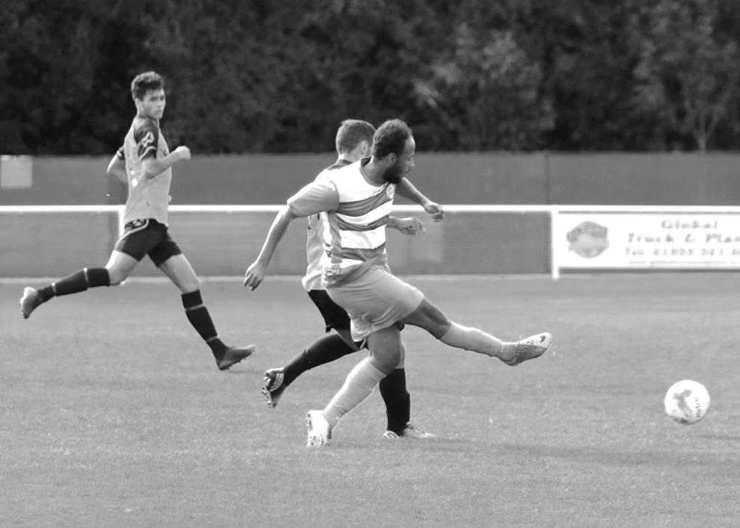
This had been a fine, hard-working performance but against Cove, bottom of the league without a point to their name, it looked as if we had just looked at the league table and thought we only had to turn up. We were wrong and trailed twice before a generous penalty award gave us a chance to draw level at 2-2 and in the 87th minute Campbell registered his first goal for the club with an important winning goal. (see picture below) We then celebrated the Club Centenary at Epsom Golf Club that evening.

If we thought we’d been lucky we didn’t take advantage of it as we then travelled to the new Meadowbank Stadium for a midweek meeting with Dorking Wanderers Reserves, Managed by our former Coach Jordan Clark. Despite leading 2-1 at the half we were exposed badly in the second period and conceded four goals and Campbell’s second goal for the club in four days, coming in injury time, was little consolation from a 5-3 defeat.

We needed to bounce back urgently against unknown package Tooting Bec at High Road and we

got off to a flying start with an early two goal lead. However, the rest of the match was a struggle as they pulled one back and took the game to us. We escaped after a late penalty gave us a 3-1 win but it was clear that thoughts of dominating this league and bouncing back at the first attempt were looking extremely fanciful.

We put those thoughts behind us and defeated FC Deportivo Galicia by three clear goals the following Saturday and followed this up with a comfortable, if tight 1-0 win at home to Bagshot in the League Cup but disaster appeared to be looming large on the horizon as we trailed Fleet Spurs at half time. Like Cove, they didn’t have a point at this stage, yet there appeared no urgency from our Management team as they ambled off at the break. We then went further behind early in the second half. Luckily Scott Murphy inspired the troops and it was substitute Germaine Jeannoel who made the difference, scoring neatly to reduce the arrears with fifteen minutes left before Sean White equalised. Finally, Jeannoel then scored an injury time winner to pinch a most unlikely 3-2 victory. (see picture below with Germaine mostly obscured by the goal post!)

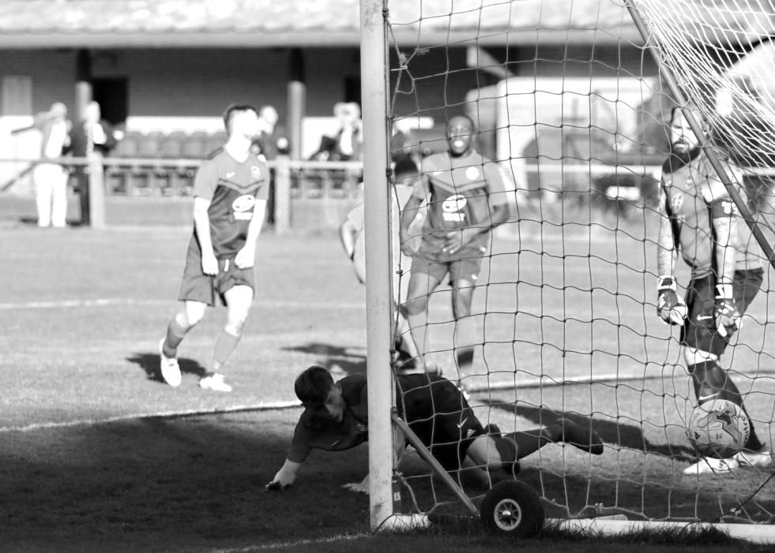
Yet again though, we didn’t learn from our mistakes and against Sheerwater it cost us again. We led 1-0 early on through a first goal for the club from Olly Martinez but lost the lead soon after and were behind yet again at the break. Endrit Dobraj rescued things with a fortuitous equaliser that was fumbled in by the club’s Manager, filling in between the posts, but despite all of this in our favour, a late goal condemned us to a 3-2 defeat against another of the promotion chasers.

Four days later on a Wednesday evening we let another lead slip and again conceded a late goal as British Airways defeated us 3-2 at their temporary home of the Orchard. These defeats left our promotion hopes hanging by a thread and with there being stories of issues within the dressing room, not to mention a few social media comments, the Committee decided to take action and following substantial discussion, sacked Neil Grant the following Monday.

Simon Funnell was offered the role, initially on a caretaker basis for the tough trip to Farnham

Town where on a very poor surface that didn’t suit our wingers the home side beat us 4-1. However, despite being in charge for just five days by this point, it was clear that the atmosphere had already lightened considerably. Funnell and his Assistant Matt Drew would speak with the Committee after every match and provide feedback. It was like a breath of fresh air and with the players clearly happier it was just a matter of turning results around.

Knaphill under 23s were the next opponents as we made our first entry into the Surrey Premier Cup after 84 years in the Senior version. It was hard to gauge the standard of some of these teams but we wore them down and in the end finished up as 5-0 victors. More challenging matches were coming up though and next was our visit to Chalky Lane for the return fixture with Chessington & Hook United. It didn’t start well! Campbell had by now left the club and appeared at Chalky Lane, becoming involved in an incident with Murphy that resulted in our player being sent off. Worse followed as we then went behind on the half hour, but a Bennett equaliser right on half time changed the match and we ran away with it in the second half, scoring three more goals despite going up the hill to win 4-1. They weren’t so fond of our celebrations at the final whistle and it has to be said that relations between the clubs are not at their best right now, with public accusations of “tapping up” their players being accompanied only by a lack of concrete evidence. This is inevitable with local clubs and the frequent transfer of players between them over the seasons as Jamie Watts and later Louis Chin would join us from them.
Below: Lloyd Connelly puts us ahead at Chessington & Hook United with a great header

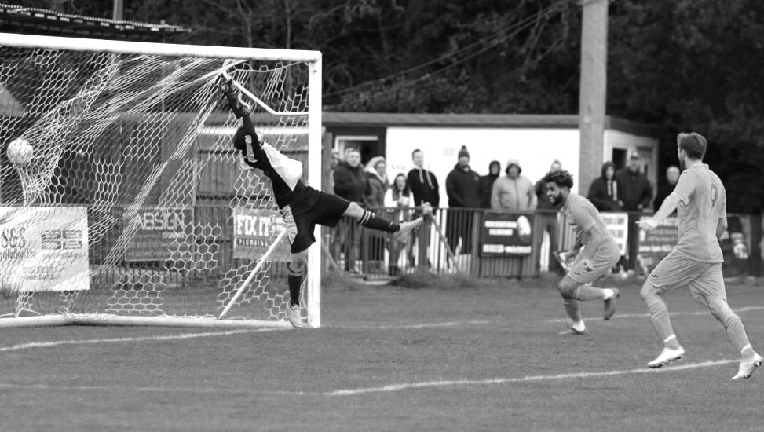
The following Saturday, a side weakened by suspensions and injuries faced a challenge from another contender in Frimley Green. However, a superb low strike from the returning Rob Hendry sent us on our way added to an own goal and by the time Roberts scored a third in the second half, we were rampant, with only a second yellow being shown to our winger killing the momentum and we had to settle for 3-0 when it could have been more.

We then hosted a revitalised Sandhurst Town in the opening round of the Division One Cup where we really had to fight hard to win, edging through with a low Hendry strike in extra time being the only goal. This was sufficient for the Committee who then bestowed the permanent title on our Manager.

Ash United were our next victims as we thoroughly battered them and their late injury time goal

gave the final scoreline of 2-1 a really harsh look as we were four goals better than them at least. However, our failure to take chances was repeated in the next match at home to Kensington Borough and we were held 1-1 at High Road. This wouldn’t have been so serious had it been an isolated result, but the damage caused earlier in the season meant that every dropped point was vital now and within the week the removal of AC London was also confirmed, costing us a further three points before we then threw three of our own away in a 2-1 defeat at Eversley & California!

From that point, things improved notably. We had eased past Dorkinians in the Surrey Premier Cup and responded well to our league defeat by battering Dorking Wanderers Reserves 3-0 on the Tuesday at High Road. This was followed by a home match against Godalming Town; one of Funnell’s previous clubs now Managed by one of our former players in goalkeeper Les Cleeveley and the G’s raced off to a 2-0 lead in the first five minutes before we fought back to equalise.
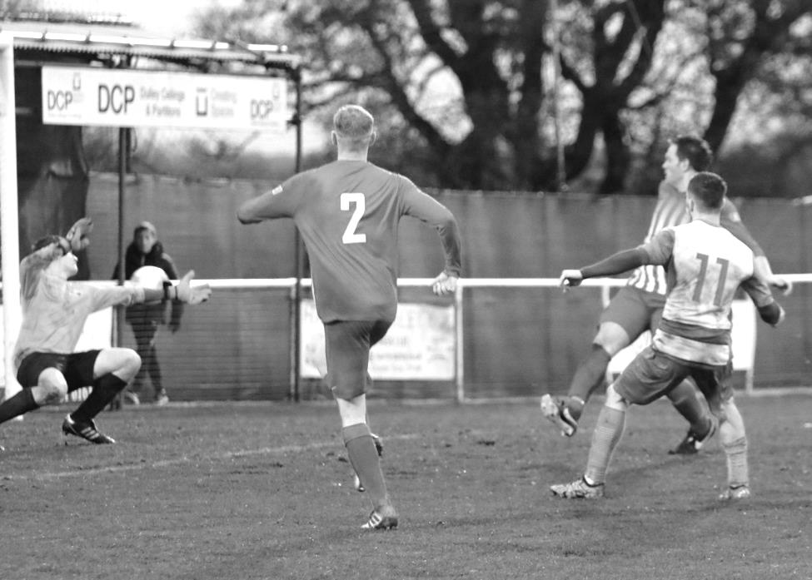
Then in the 63rd minute we had “Stanchiongate” as Scott Murphy’s winning strike appeared to come back off the far post and into play again, but something felt weird about what I’d just seen, and others behind the goal with younger eyes were convinced it had hit the diagonal post located just inside the Chipstead goal frame and was in fact actually a goal. Clearly the Assistant was similarly uncertain and when our bench started telling him what had happened, to his credit he raised the flag and told the referee, leading to our winning goal being awarded some thirty seconds after we had scored it!

We followed this up with an exciting encounter with runaway leaders Bedfont & Feltham. We went behind early, but were back on level terms through Hendry soon after and went on to lead on three occasions. Each time they fought back to equalise; the final goal coming in the 90th minute. It was a sickener, even though we knew that we were perfectly capable of beating them when we would next meet in the Division One Cup Quarter-Final in February.
Liam Roberts puts us 3-2 up against Bedfont & Feltham after a dazzling run and strike

A two week break ensued as we had a week off followed by a postponement at Sheerwater which was due to landlords Woking calling the match off a few days early. It gave us a bit of notice I suppose but the League were livid and Sheerwater were mighty fortunate that they didn’t have the points docked, which could have led to serious consequences for their title challenge. As it was, we’d go there in March, but we then saw the old year out with a 1-0 victory over Eversley & California; the winner coming from a scuffed shot by Bennett that completely caught the keeper out due to the lack of pace on the ball, although it was maybe just as well it wasn’t hit with too much power as it came back out off of the diagonal stanchion again!

It was another three points and we went into what looked like a kind sequence of fixtures as we tried to catch the top teams. First up were improving but struggling Cove and as with the first match in September they led us again, with our boys not pulling it out of the fire until the second half when a deflected Reisse Griffin header was largely eclipsed when a goal of total class from Hendry proved to be the winner. He turned some 35 yards out from goal and from an awkward angle, most wouldn’t have even been thinking to hit it, but he did and the shot flew over the keeper and bounced up into the net! Below: Reisse Griffin heads the equaliser against Cove

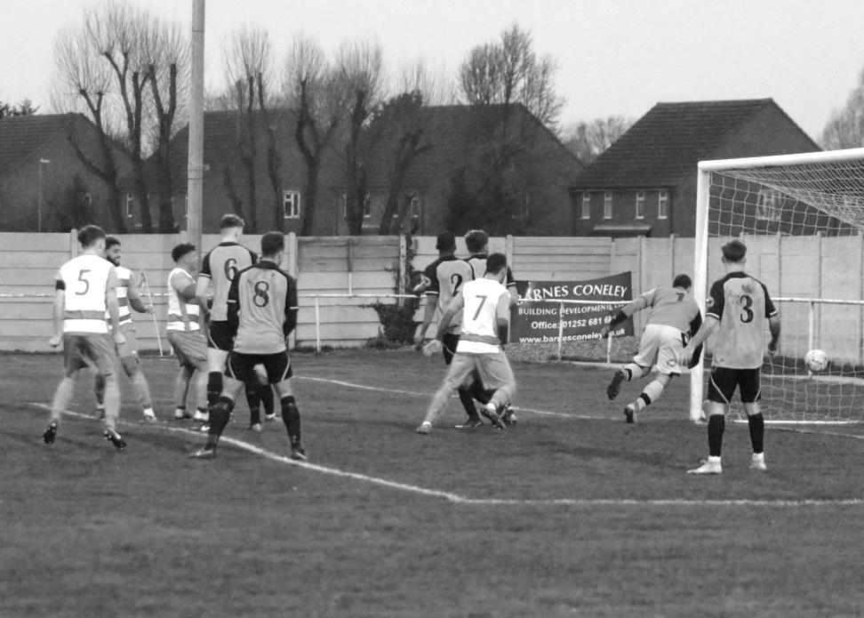
Yet again though we followed a lucky escape with more dropped points as we led Ash United with a Hendry drive (that also came back out off of the stanchion!) but went into negative mode when we should have been looking for more goals and got caught as the visitors equalised with a penalty. The following week against Bagshot we were hanging on to a 2-1 lead but on this occasion it was our opponents that folded as we scored five times in the last twenty minutes to win 7-1!

Even a week later in the return match against Godalming a similar story followed as we sat back after leading and predictably conceded an equaliser, but then played some good stuff to restore the lead and went on to win 3-1. New players Billy Carney, Hakim Griffiths and Ben Chick had added competition for places and this was proving a successful move by the Manager.

But how good were we? We were about to be tested by Bedfont & Feltham again in the Quarter-Final of the League Cup at the Orchard. We failed to take some good early chances and then went behind right on half time, but fought back well and clinched the tie by two goals to one. In truth 5-1 wouldn’t have been unfair as we dominated much of the match, although did require an injury time penalty save from Conor Young to preserve the win and avoid extra time.

We then crushed Godalming Town 5-1 in a League Cup tie and edged past British Airways 3-2, with both wins coming at High Road and were in superb form. Unbeaten at home under Simon Funnell, continued interest in three cups and with nine wins in eleven matches, everything looked rosy. But then the wheels fell off!

Following the very interesting photo shoot on Wednesday 20th February after we had been selected as the face of the Match Day App (see below picture and website article) we travelled to Imber Court for the Quarter Final of the Surrey Premier Cup in excellent form to play their Academy side, but trailed 2-0 early; a trait that seemed to be happening more and more and whilst we drew level at 2-2, we were behind again at half time and despite pressing for an equaliser, a fourth goal was conceded on the break.
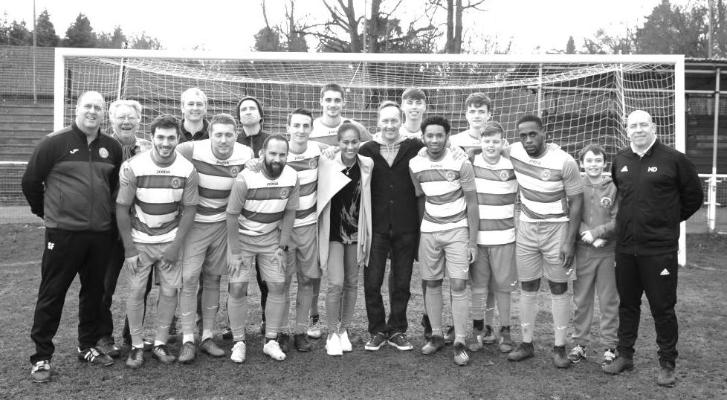
Worse was to come as we had worked so hard to retrieve our League position, only to throw it all away in the first half at Frimley Green, going 3-0 down to a combination of errors and a highly suspicious third goal which Frimley credited to their keeper, largely as they couldn’t give it to their striker Dan Bone as he had punched the long ball from Chris Harris into our net! We went 4-0 down before pulling a couple back but this defeat really hurt our season and it’s fair to say we haven’t really recovered from it yet.

We had a Saturday off before facing Step Five Abbey Rangers in the Quarter-Final of the League Cup where we competed well for 45 minutes, only to concede three goals in a ten minute spell just after the break with another Hendry rocket providing just a consolation on this occasion. Then on the Saturday an early and harsh sending off for new boy Jake Robinson at Fetcham Grove against Kensington Borough killed our chances and we trailed 5-0 at the half. A measure of how bad we had been came in the second forty-five when despite having ten men we were the better side and actually reduced the arrears through Chick.

We then came up against a very strong Sheerwater team who comfortably beat us 3-0 and were

without doubt the best team we had faced all season. These results left us with nothing to aim for by way of promotion and we then subsided meekly at Tooting Bec on the Grand Drive ploughed field by four goals to one, despite a goal from the recently returned Jordan Gallagher.

Six away matches in a row had produced six defeats and our club record equalling seventh away match was at the Bedfont Sports Club where we faced FC Deportivo Galicia in the Semi-Final of the Division One Cup. Again early chances went begging, but a top corner Hendry free kick broke the deadlock and Griffin headed a second just before the interval. We extended the lead to 4-0 before Carney was tripped for a penalty, only to see the referee decide instead that he had dived and gave him a second yellow card, a quite atrocious decision as we could have gone on to win by six or seven, but instead they pulled two back to make the scoreline far less convincing.

And we were less than impressive three days later as we were extremely fortunate to secure a point at home to Fleet Spurs, thanks to a great strike from Hakim Griffiths (see below).

Bearing in mind the recent form, the following Saturday’s result came as somewhat of a surprise as we defeated Bedfont & Feltham by the astonishing margin of six goals to four! Griffiths netted four of these, becoming only the second player to achieve this for the club since 1998, as we showed our entire season in one match, working hard to lead 2-0 then blowing it all away again in just four minutes, before leading 4-2 with some individual brilliance, only to then lose concentration and get pulled back to 4-4 before pushing on to win in injury time.

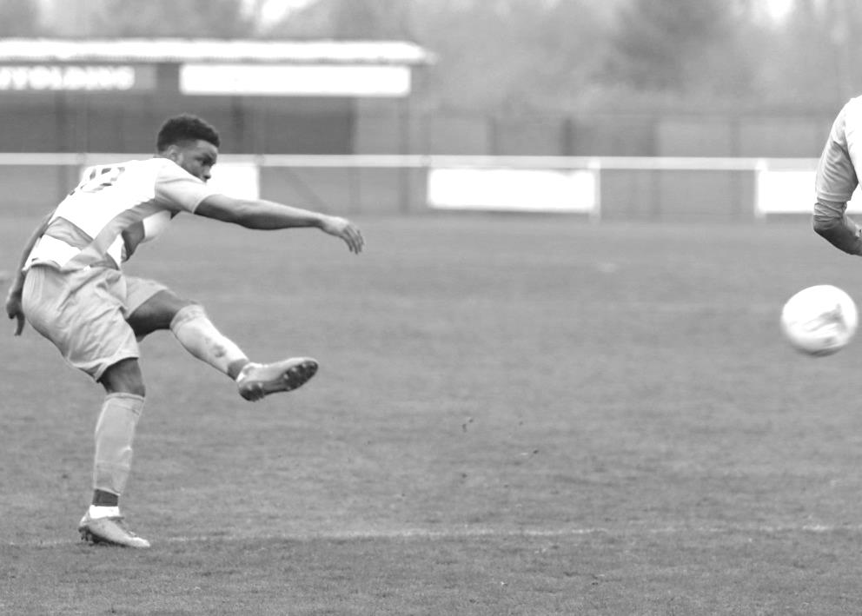
However, any positives from this match were completely wiped from our memories three days later as we threw in a complete stinker at home to FC Deportivo Galicia, who we had already beaten twice, yet barely registered a shot of any threat in the whole ninety minutes to surrender our six month unbeaten home record by a score of 2-0, the second of which came when they had been reduced to ten men, just to increase the embarrassment.

Last Saturday we hosted Sandhurst Town and suffered a second straight home defeat, which brings us to today’s league finalé. Here’s hoping we can finish the season with two wins.

In keeping with some previous summaries, here is my personal view on our Goal of the Season and I list a few of our best ones below. I hope many of them jog your memories!

Liam Roberts – 25th August v Beckenham Town (A)(FAC) – a great run and strike into the top corner to force a replay in a 2-2 draw. His first goal was a smart finish too, into the bottom corner.

Germaine Jeannoel – 29th September v Fleet Spurs (A)(L) – a nice run and low finish just inside the near post that started the fightback from 2-0 down to win 3-2 in injury time

Reisse Griffin – 10th October v British Airways (A)(L) – a thumping header from a pinpoint Olly Martinez left wing cross

Bobby Bennett – 27th October v Chessington & Hook United (A)(L) – some nice control and a low cross shot into the bottom corner to draw the ten men level and inspire the second half upset

Rob Hendry – 3rd November v Frimley Green (H)(L) – a early low instinctive shot inside the near post from distance that set us up for a fine win on the day

Liam Roberts – 3rd November v Frimley Green (H)(L) – cutting in from the left and casually stroking the ball into the far corner as easy as you like

Elliott Thompson – 20th November v Dorkinians (H)(SPC) – Beating three men from a central position before casually guiding the ball beyond the keeper for a classy finish (Second place)

Adam Heagney – 24th November v Eversley & California (A)(L) – A smart goal, started and finished by our man, playing at left back involving some interplay with Roberts and Hendry

Rob Hendry – 27th November v Dorking Wanderers Reserves (H)(L) – a smart volley at the far post from a Bobby Bennett cross

Hakim Griffiths – 8th December v Bedfont & Feltham (H)(L) – quick feet and a smart low finish to put us 4-3 up on his debut

Ben Chick – 19th January v Bagshot (H)(L) – recognised that the keeper had been drawn out from his goal and cleverly clipped the ball beyond him into the net from twenty yards

Billy Carney – 26th January v Godalming Town (A)(L) – a good run, beating two men before finding Hakim Griffiths who returned it for Carney to finish with a low drive

Reisse Griffin – 12th February v Godalming Town (H)(LC) – another great header from a Rob Hendry cross that went in off the bar and up into the roof of the net

Rob Hendry – 5th March v Abbey Rangers (A)(LC) – another superb long range strike that went in off the keeper’s left post

Rob Hendry – 3rd April v FC Deportivo Galicia (A)(Div 1 LC SF) – a stylish free kick into the top corner from twenty yards to put us ahead in the big cup tie

Hakim Griffiths – 13th April v Bedfont & Feltham (A)(L) – a stunning strike from twenty-five yards that flew into the far corner. What a way to get your hat trick! (Third place)

Jordan Gallagher – 13th April v Bedfont & Feltham (A)(L) – was heading away from goal but then turned back, beat his man and from a narrow angle slid the ball beyond the keeper

And the winner is:

Rob Hendry – 5th January v Cove (A)(L) – a wonderful strike from forty yards at an angle, over the keeper and into the net

Also: Bizarre goal of the year – Rob Hendry – 27th October v Chessington & Hook United (A)(L) – the keeper’s clearance was blocked by the jumping Hendry’s back, with the ball rebounding into the net from eighteen yards out! Very funny and couldn’t have happened against a nicer team!

Turning the corner, hopefully!
There is no getting away from it, as we made quite clear at the start of the season. Our aim was to go straight back up and as a club we have failed in our attempts. However, it was not for the want of trying or taking our eyes off the ball, as was arguably the case last season.

It is sad to report this with a cup final on the horizon, but it was hoped that we’d only have one try at the Division One Cup before re-joining the others at Step Five and consigning the last couple of seasons to ancient history. It hasn’t happened and for a number of reasons.

Obviously the first of these was the slow start made to the season which resulted in the dismissal of Neil Grant after only nine months in the role. I could go into detail, but will keep things brief by saying that we learned a lot about Neil during the tail end of 2017/18 and improvements were required in a few areas, but he chose not to address them, becoming more isolated and aloof. When results started to slip, we could have kept him on for longer, had other areas been satisfactory, but he didn’t help himself and the Committee had to act.

Our new Management team’s first task was to steady the ship and bring back the harmony once again. Simon was in effect, our Ole Gunnar Solksjaer, and he has done a fine job in this area, and equally importantly by working in tandem with the Committee, which was something Grant had difficulty with. Simon will by now be aware of our views for the upcoming season and I feel certain that he will take these on board and we will see continued improvements for 2019/20. He has already identified a number of players for next season who will be devoted to the cause.

Will it be enough? This is football, it is an unpredictable sport and that is one of the reasons we all love it so much. I have no answer for you. No one knows. All we can do is support our Manager in his aims and trust that he gets the balance right and that we are celebrating this time next year.

One of my favourite sayings is that life is all about timing. The fates certainly conspired against Neil and our club when it became clear that only the Champions were guaranteed promotion after decades of the top three clubs going up. In fact, last season Raynes Park Vale went up from a position of fifth place. There would be no such luxury this season.

Maybe next year things will turn in our favour and we are already hearing rumours saying that as many as four or five clubs from each division could go up as the F.A. Pyramid reorganisation completes its final stage. At the end of next season there will be an extra Step Four League and two extra Step Five leagues created and these clubs are almost all coming from Step Six with only one down next year from Steps Four and Five I am hearing.

It could be an exciting season. We have an almost certain trip to Jersey coming up, although there must be a serious doubt about our participation in the F.A. Cup. This is obviously not good news as it would be our first non-appearance since 1972/73 but it just focusses our requirement to be back up to Step Five as soon as possible.

And I haven’t mentioned the new ground situation yet. As Pete almost certainly would have referred to in his piece we are still in negotiations with the majority Residents Association part of the Borough Council and will pick up with them once the May elections have concluded. If a Councillor comes knocking on your door, then please tell them that they need to support the return of the club to the Borough. There have been recent delays on this caused by the creation of the Borough Plan, for which we are hoping to be included on, but there is pressure on them to build a number of houses too, which leaves them reluctant to fully and openly commit to us right now, but it is hoped that we can really push this forward, during the summer and autumn months and have more positive news towards the end of the year with a clear aim towards our preferred

site at the Hook Road Arena.

Now, in my review last year, some of you will recall that I was critical of every adult supporter last season because we all could have helped the club more in its hour of need. I was personally critical of many Committee decisions, or more relevantly, non-decisions, but one thing we have clearly done this season is to learn from our mistakes. This enabled us to spot the warning signs earlier this time and act decisively in ending Neil Grant’s tenure.

Part of the problem came before this. Glyn Mandeville was here for many years and was a good friend of the club and many of us in it. This made our decision to dispense with his services a more personal one, which added to the difficulty. We never afforded Neil that opportunity as he never sat on the Committee. This is a policy we have continued under Simon Funnell, although he provides substantial feedback to us each and every match, so it is to him that my first thank you of the season goes, for purely and simply putting the fun back into the club after a very dark spell. Matt Drew his Assistant has been equally helpful and the Management Team has been completed by Paul Marshall and more recently Chantelle Farrell our Physio who was thrown in at the deep end by having to make a difficult decision with one of our players to protect them against further injury. Our team will be given every support as they chase promotion next year.

Paul is of course also a Committee member and it is to the Committee that I turn next. Everyone knows the amount of work that our Chairman and Vice-Chairman put in and of course Pete Beddoe and Steve Dyke both hold two roles at the club. Pete is also Club Secretary while Steve is also Treasurer and whilst Pete has had a slightly easier season than last in terms of admin, Steve has now managed to wrest back control of the player budget after a number of years where it had previously been a matter of giving the Manager the money and hoping it was spent wisely.

Gary Jarman and Membership Secretary Mel Tough have also been important to the cause and were fully involved in the decisions relating to the Manager back in October. Additionally, Mel was the main driver behind our Centenary Evening, selling a great many of the tickets himself and ensuring a great and self-financing night for all. Yours truly brings the number of Committee Members to six, although we may be losing Paul this year as he is resigning as Kit Man and Hospitality Officer to spend a bit of time pursuing other interests. It is to be hoped that he will remain on the Committee, but at such an important stage in the new ground process, we would always be looking for more volunteers, regardless of whether Paul was staying or not.

If you feel that you can bring anything to the club, please let us know. You DO NOT have to be a regular supporter or be at all the matches, but if you can help, then let’s have the conversation! There are so many little things that could be done that would benefit the club, but which would take up time that me, Pete and Steve in particular do not have available.

I repeat my observation of last year, where I advised that we should all look at our roles over the course of every season and assess whether we could have done better. On this occasion I think we have at least matched, if not exceeded your expectations, and this year are most definitely deserving of your thanks.

Away from the two management groups, we have again had excellent support from Gemma Jarman who provides an enormous number of fantastic photos at almost every match and is now also putting some live feeds on to Instagram, showing some of our goals. I’m not sure how she manages to do some of these tasks all at the same time, although I know that Gary has been helping with some of the filming too. Also, George Holland has been helpful by summarising the match reports for the local papers, while Sam Dyke has taken on the role as Match Day Announcer and (when the P.A. system works!) has proven to be very helpful.

One thing that has been apparent at most of the matches we’ve been to is the number of supporters we take. Our regular loyal supporters go to most of the matches, whether home or

away and we outnumber the opposition frequently in this division. Almost all have sponsored a match or a player, or both at some point and this is greatly appreciated. It is hoped that we will all give you a lot more to celebrate next season.

We must also thank our landlords Chipstead F.C. and can confirm that we will be remaining at High Road next season. This at least provides us with the facilities that we may desire, if not the playing level and we also know that the “Chipstead Sponge” will continue to ensure that very few of our matches bite the dust. Bretty is an excellent groundsman and Keith and Katie have been very helpful to us on match days with the drinks and food respectively. Finally, I will thank Jessica Ramsey and Advertising Agency Cake UK who dealt with the PayPal UK photo shoot in February and arranged some funding for us.

As I wrote last season, please give some thought over the summer to what YOU can do for the club. If you are in doubt, come and ask a Committee Member and we can try to match you up with any particular skill set you may have.

At times I feel like putting a swingometer onto the website, indicating our chances of getting a new ground, which has ebbed and flowed massively over the 26 seasons of exile from our Borough. For the last twelve months now I would have had this meter showing at around 50% - 60% and I see no reason to change its position currently. This is positive news and it would be nice to push that meter a little higher in the Autumn. Rest assured that we will be doing all we can to make it happen, but don’t rest too easy, as any announcement of a new ground will only be the start of the hard work and we will need your help to make it happen too.

See you all at the Cup Final on Bank Holiday Monday!

Club Statistical History - (including Sandhurst Town (H) on 20/04/19):
League: Played: 2,956, Won: 1,211, Drawn: 563, Lost: 1,182
For: 5,439, Against: 5,258, GD: plus 181 - Win Ratio 40.97%

CCL only: Played: 535, Won: 237, Drawn: 105, Lost: 193
For: 973, Against: 872, GD: plus 101 - Win Ratio 44.30%

Cup and Other (inc Abandoned Matches):
Played: 1,129, Won: 536, Drawn: 130, Lost: 455 Abandoned: 8
For: 2,454, Against: 2,113, GD: plus 341 - Win Ratio 47.48%

Under Simon Funnell: Played 31, Won: 17, Drawn: 4, Lost: 10
For: 75, Against: 59, GD: plus 16 - Win Ratio 54.84%

Total: Played 4,085, Won: 1,747, Drawn: 693, Lost: 1,637, Aban: 8
For: 7,893, Against: 7,371, GD: plus 522 - Win Ratio 42.77%

First Senior Match: 30th August 1924. Lost 1-3 vs Dorking (H) at Horton Hospital Grounds.

Record Win: 12/10/1935 - 13-1 v Reigate Priory (H) - Amateur Cup.

Record Defeat: 14/02/1948 - 0-14 v Chelmsford City Reserves (A) - London League.

Most Appearances in a season: Tony Coombe and Tommy Tuite - 59 in 1980/81.

Most goals in a season: Reg Marlow - 65 (at least) in 39 appearances in 1926/27.

Senior League Titles: 5 - 1925/26 Surrey Senior League - 1926/27 Surrey Senior League - 1927/28 London League - 1974/75 Surrey Senior League - 1977/78 Isthmian League Division Two

First Eleven Appearances - (max 47)
Name | Debut | 2018/19 |  |  |  | Career Totals
Name | Debut | App | Sub | Tot | Goals | App | Sub | Tot | Goals
BENNETT Bobby | 12/08/2018 | 39 | 0 | 39 | 23 | 39 | 0 | 39 | 23
BETANCOURT Steve* | 18/08/2018 | 21 | 1 | 22 | 1 | 21 | 1 | 22 | 1
BORRETT Ricky* | 04/08/2018 | 9 | 0 | 9 | 0 | 9 | 0 | 9 | 0
BROWN George | 09/03/2019 | 0 | 1 | 1 | 0 | 0 | 1 | 1 | 0
CAMPBELL Kieran* | 29/09/2012 | 7 | 3 | 10 | 2 | 59 | 3 | 62 | 2
CAMPBELL Theo* | 28/08/2018 | 2 | 9 | 11 | 1 | 2 | 9 | 11 | 1
CARNEY Billy | 12/01/2019 | 12 | 4 | 16 | 6 | 12 | 4 | 16 | 6
CAULCRICK Joshua* | 17/02/2018 | 0 | 4 | 4 | 0 | 0 | 5 | 5 | 0
CEESAY Sheikh* | 23/02/2019 | 1 | 0 | 1 | 0 | 1 | 0 | 1 | 0
CHICK Ben | 29/12/2018 | 7 | 8 | 15 | 3 | 7 | 8 | 15 | 3
CHIN Louis | 08/12/2018 | 13 | 1 | 14 | 0 | 13 | 1 | 14 | 0
CONNELLY Lloyd | 14/10/2017 | 46 | 0 | 46 | 4 | 76 | 4 | 80 | 6
DOBRAJ Endrit* | 18/11/2017 | 5 | 2 | 7 | 1 | 24 | 6 | 30 | 1
DYSON Ben* | 12/08/2017 | 0 | 1 | 1 | 0 | 28 | 14 | 42 | 2
EASTGATE Sam | 09/03/2019 | 0 | 1 | 1 | 0 | 0 | 1 | 1 | 0
ELGAR Luke | 04/08/2018 | 15 | 4 | 19 | 2 | 15 | 4 | 19 | 2
ELGAR Scott* | 12/08/2018 | 4 | 9 | 13 | 0 | 4 | 9 | 13 | 0
GAFFNEY Luke * | 16/08/2014 | 2 | 2 | 4 | 0 | 12 | 3 | 15 | 0
GALLAGHER Jordan | 07/08/2016 | 6 | 0 | 6 | 3 | 47 | 13 | 60 | 17
GAYLE Roy* | 06/11/2018 | 3 | 3 | 6 | 0 | 3 | 3 | 6 | 0
GILL George* | 28/08/2018 | 2 | 0 | 2 | 0 | 2 | 0 | 2 | 0
GRIFFIN Reisse | 08/08/2015 | 26 | 0 | 26 | 5 | 130 | 13 | 143 | 13
GRIFFITHS Hakim | 08/12/2018 | 11 | 3 | 14 | 9 | 11 | 3 | 14 | 9
HEAD Chris | 09/03/2019 | 0 | 1 | 1 | 0 | 0 | 1 | 1 | 0
HEAGNEY Adam | 16/08/2016 | 45 | 0 | 45 | 1 | 112 | 13 | 125 | 3
HENDRY Rob | 08/08/2015 | 24 | 1 | 25 | 18 | 108 | 24 | 132 | 46
JEANNOEL Germaine* | 02/12/2017 | 1 | 10 | 11 | 2 | 3 | 17 | 20 | 3
JONES David* | 31/08/2018 | 6 | 2 | 8 | 0 | 6 | 2 | 8 | 0
LOFTUS-CHEEK Joe* | 06/08/2017 | 0 | 1 | 1 | 0 | 14 | 8 | 22 | 6
MARTINEZ Olly | 29/09/2018 | 10 | 4 | 14 | 2 | 10 | 4 | 14 | 2
MCKAY Alex | 20/12/2008 | 1 | 0 | 1 | 0 | 163 | 39 | 202 | 13
MORGAN Sam | 11/09/2018 | 3 | 8 | 11 | 0 | 3 | 8 | 11 | 0
MURPHY Scott | 20/01/2007 | 42 | 0 | 42 | 5 | 89 | 2 | 91 | 9
MURPHY Todd | 27/11/2018 | 2 | 9 | 11 | 0 | 2 | 9 | 11 | 0
ROBERTS Liam | 12/08/2017 | 27 | 7 | 34 | 12 | 48 | 21 | 69 | 17
ROBINSON Jake | 23/02/2019 | 7 | 1 | 8 | 0 | 7 | 1 | 8 | 0
SMITH Taryn* | 28/10/2017 | 6 | 7 | 13 | 5 | 14 | 11 | 25 | 5
SULLIVAN Ryan | 04/08/2018 | 28 | 2 | 30 | 0 | 28 | 2 | 30 | 0
SUTHERLAND Mitchel* | 04/08/2018 | 1 | 1 | 2 | 0 | 1 | 1 | 2 | 0
THOMPSON Elliott | 09/02/2016 | 28 | 8 | 36 | 1 | 38 | 17 | 55 | 2
WATTS Jamie | 03/11/2018 | 8 | 1 | 9 | 1 | 8 | 1 | 9 | 1
WHITE Sean* | 02/08/2014 | 9 | 4 | 13 | 4 | 29 | 25 | 54 | 9
WOODCOCK Josh | 22/09/2018 | 8 | 0 | 8 | 0 | 8 | 0 | 8 | 0
WRIGHT Kieran* | 15/09/2018 | 3 | 3 | 6 | 0 | 3 | 3 | 6 | 0
YOUNG Conor | 07/03/2015 | 27 | 0 | 27 | 0 | 60 | 0 | 60 | 0
Plus one own goal * - Player has left the club

Farnham Town – History
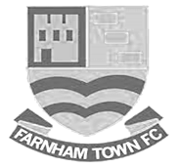
Farnham Town Football Club is a senior level football club based In Farnham, Surrey, England.

Established in 1906 through the merging of Farnham Bungs (the Farnham Brewery) and the Farnham Star. The club was one of the founder members of the London Spartan League in 1975. They reached the Fourth Round of the FA Vase in the 1976-77 season.

At the end of the 1979/80 season Farnham Town left the London Spartan League and applied to the Combined Counties League, their application was accepted and they finished 4th in their first season. The 1986/87 season saw Farnham take second place to Ash United in the league campaign. The glory days finally arrived in the 1990/91 season when the club won the league title. In the 1991/92 season, the Town got a clean sweep of the major trophies by winning the Combined Counties Premier League, the Dan Air Elite Cup and the Dan Air Challenge Cup. Having won the league, the club applied and were accepted to the Isthmian League. However funds for necessary ground improvements could not be generated which resulted in the club not having a league to play in for the 1992/93 season.

In 1993/94 Farnham Town were accepted back into the Combined Counties League where they continue to ply their trade. From 1995-1998 Farnham finished in the top six of the Premier Division for three consecutive seasons, in 1998-99 they finished in 13th position, then 10th in 1999-2000 before suffering relegation from the Premier Division in 2000-2001 season. They bounced straight back the following season but then endured four tough seasons back in the Premier Division, with bottom four finishes every season culminating in relegation back down to Division One in 2005-2006. Again, the club bounced straight back and in 2006-2007 they won the Division One title under the guidance of Barry Bridger, but were denied promotion due to the Memorial Ground not meeting the desired grading by the league. The club then spent another four seasons in Combined Counties Division One.

Farnham gained promotion from Combined Counties Division One in the 2010-2011season after finishing second behind Worcester Park. In Paul Tanner’s first season at the helm he gained automatic promotion back to the Premier Division at the first attempt, which after only retaining four members of the side from the previous year’s squad - who finished mid-table, was quite an achievement.

Paul Tanner’s side also won the Combined Counties Fair Play Award for 2010-2011 after going the whole season without having a man sent off, a record to be proud of. In a very successful year for the club on the whole, Dean Nelson’s reserve side finished second behind Mole Valley in the Combined Counties Reserve Division, improving on fourth position the previous season. Farnham Ladies also finished second in their respective league to cap quite a remarkable season in Geoff Chapple’s final season as Chairman. In 2011, Ray Bridger took over as chairman from Geoff Chapple.

2017/18 didn’t go well for the club and Tanner left his role towards the end of a season that left them at the foot of the table, alongside Epsom & Ewell and Godalming Town and Dan Turkington took on the position with a brief of gaining promotion for 2018/19.

CCL Division One Club Directory
AC LONDON: Telephone: 0208 660 5491 - Colours: Orange/Black/Black
Ground: Whyteleafe FC - 15 Church Road, Whyteleafe. CR3 0AR

ASH UNITED: Telephone: 01252 344264 - Colours: Green with Red Trim/Green/Green
Ground: Shawfields Stadium, Youngs Drive, Shawfields Road, Ash, Aldershot. GU12 6RE

BAGSHOT: Telephone: 01252 623804 - Colours: Yellow/Black/Black
Ground: Fleet Town FC - Calthorpe Park, Crookham Road, Fleet. GU51 5FA

BEDFONT & FELTHAM: Telephone: 0208-890 7264 - Colours: Yellow/Blue/Blue

Ground: The Orchard, Hatton Road, Bedfont. TW14 9QT

BRITISH AIRWAYS: Telephone: 0208-890 7264 - Colours: Sky Blue/Navy Blue/Navy Blue
Ground: Bedfont & Feltham FC - The Orchard, Hatton Road, Bedfont. TW14 9QT

CHESSINGTON & HOOK UNITED: Telephone: 01372-602263 Colours: All Blue
Ground: Chalky Lane, Chessington. KT9 2NF

COVE: Telephone: 01252 543615 Colours: Yellow/Black/Black
Ground: Oak Farm, Squirrel Lane, Cove GU14 8PB

DORKING WANDERERS RES Telephone: 01306 400151 - Colours: Red & White Stripes/ Blue/ Red
Ground: Meadowbank Stadium, Mill Lane, Dorking. RH4 1DX

EPSOM & EWELL Telephone: 01737-553250 - Colours: Royal Blue & White Hoops/Royal Blue/Royal Blue - Ground: Chipstead FC, High Road, Chipstead. CR5 3SF

EVERSLEY & CALIFORNIA Telephone: 0118 973 2400 - Colours: - White & Royal Blue Hoops /Royal Blue/ Royal Blue - Ground: Fox Lane, off Reading Road, Eversley. RG27 0NS

FARNHAM TOWN Telephone: 01252 715305 - Colours: - Claret & Sky Blue /White/ Claret & Blue
Ground: Memorial Ground, Babbs Mead, West Street, Farnham. GU9 7DY

FC DEPORTIVO GALICIA Telephone: 0208 831 9067 - Colours: Royal Blue/Royal Blue/White
Ground: Bedfont Sports FC - Bedfont Sports Club, Hatton Road, Bedfont. TW14 9JR

FLEET SPURS Telephone: 01252 662810 - Colours: Dark Blue with Red Trim/Dark Blue/Dark Blue
Ground: Kennels Lane Farnborough. GU14 0ST

FRIMLEY GREEN Telephone: 01252 835089 - Colours: All Blue
Ground: Frimley Green Recreation Ground, Frimley Green Road, Frimley. GU16 6JY

GODALMING TOWN Telephone: 01483 417520 - Colours: Yellow/Green/Yellow
Ground: Wey Court, Meadrow, Godalming. GU7 3JE

KENSINGTON BOROUGH Telephone: 01372 360151 - Colours: All Blue
Ground: Leatherhead FC – Fetcham Grove, Guildford Road, Leatherhead. KT22 9AS

SANDHURST TOWN Telephone: 01252 878768 - Colours: Red & Black Stripes/Black/Black
Ground: Bottom Meadow, Sandhurst Memorial Park, Yorktown Road, Sandhurst. GU47 9BJ

SHEERWATER Telephone: 01483 772470 - Colours: Royal Blue & White/Royal Blue/Royal Blue
Ground: Woking FC - Laithwaite Community Stadium, Kingfield, Kingfield Road, Woking. GU22 9AA

TOOTING BEC Telephone: 0208 540 8843 - Colours: Black & White Stripes/White/White & Black
Ground: Raynes Park Vale FC – Prince George’s Playing Fields, Grand Drive, Raynes Park. SW20 9DZ

Surrey Premier Cup
Holders: Nottsborough
First Round
Carshalton Athletic U19 | w/o Ash | Ash United
Shene Old Grammarians | 2-4 | Old Wilsonians
Lingfield | 5-1 | Horley Town Reserves
Alfold | 2-0 | Godalming Town
Epsom & Ewell | 5-0 | Knaphill U23
Reigatians | 0-4 | Frimley Green
Met Police Academy | 3-3 - 5-4p | FC Deportivo Galicia
Second Round
Ash United | 3-1 | Chessington & Hook Utd
Alfold | 0-1 | Nottsborough
Old Wilsonians | 1-6 | Lingfield
Sheerwater | 5-0 | Corinthian Casuals Res
Farnham Town | 4-1 | Westfield Reserves
Epsom & Ewell | 4-0 | Dorkinian
Met Police Academy | 7-3 | Dorking Wanderers Res
Bagshot | 1-3 | Frimley Green
Quarter-Finals
Ash United | 1-3 | Frimley Green
Met Police Academy | 4-2 | Epsom & Ewell
Farnham Town | 0-0 2-4p | Lingfield
Nottsborough | 1-1 7-6p | Sheerwater
Semi-Finals
Frimley Green | 1-2 | Nottsborough
Lingfield | 2-1 | Met Police Academy
Final – 24th April 2019
Lingfield | v | Nottsborough

Today’s match – In memory of Chris Henry
On Tuesday July 13th 2004 our club lost one of its long-term supporters at the tragically young age of 46.

Chris Henry was well known to anyone that regularly attended Epsom matches in the past. He once told me that his first game was a 0-0 draw against Marlow at West Street on 25th January 1969, when he was only 11 years of age. That would have been fifty years ago this season!

In those days, a 0-0 draw was looked on as a positive result, as the team was to go through some very dark days before its resurgence and subsequent Wembley appearance in 1975.

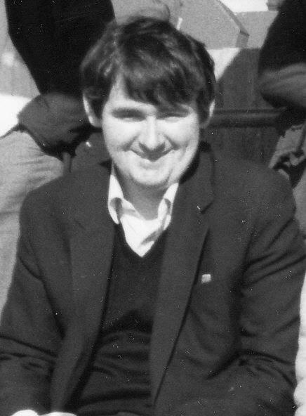
However, Chris stuck with it, supporting the club home and away throughout those bad times. Although there are a handful of older supporters who had seen the club play from an earlier date, there was no one else in my opinion that had seen as many games at the time as Chris had; only missing four or five a season on average at most during his long association with the club. He probably passed fifteen hundred matches if you include Reserve and Youth matches, of which he saw many.

I first met Chris in 1982. Both myself and John Steinmetz had started to attend some of the away games in our first season watching the club. Standing behind the goal at Wembley F.C. on 27th February 1982 we met up with Chris and Gary Vickers, and started to attend as many games as possible with them, usually taking a football with us. John, Gary and I would kick around in a nearby park, while Chris sat there watching and listening to his radio!

He may sometimes have come across to those who didn’t know him as a quiet individual, but once you could get him talking about music or football in particular, he was a changed person and would be much happier. He is in a happier place now, and we all still miss him, particularly at times like today when the game is sponsored in his memory. It is really hard to take in the fact that he has been gone for nearly fifteen years ago now.

Our thoughts also go to his sister Mary and his brother Ray and family, all of whom have been regular visitors and match sponsors over the years. Hopefully we will see them all again here today.

Cup Finals
Some of you may have noticed that we have a Cup Final coming up! In fact, our Esoteric Division One Cup Final against Frimley Green at the new Meadowbank Stadium will be our twenty-second major cup Final.

Finals are frequently difficult matches and it is no surprise to see that we have lost more of them than we have won. Of the previous 21 Finals, we have won only eight.

So I thought I would remind you of all our successes!
------------------------------------------------------------------------------------------------------------------------------------
Saturday 14th May 1927 – Surrey Senior League Charity Cup – Egham FC 0-1 Epsom Town

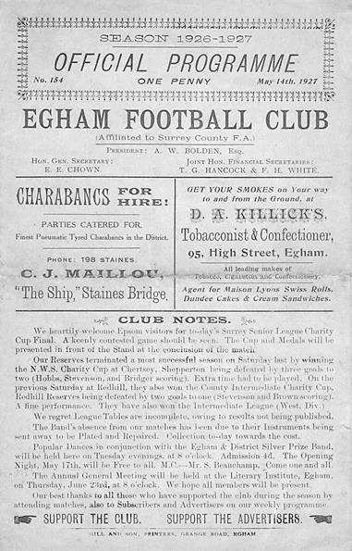
In the post war years, The Charity Cup ran alongside the League Cup as the Surrey Senior League, now of course better known as the Combined Counties League, ran two knockout competitions. These days it only runs the League Cup, but back in the twenties there was only the Charity Cup.

In a 13 team League we reached the Final by virtue of a first round bye before destroying Reigate Priory in the Quarter-Final by 7-2 at West Street. The Semi-Final was against the two-time holders Farnham United Breweries, but they were no match as we sailed through to the final with a 5-2 home win.

Maybe understandably after two home draws we faced Egham in the final on their own ground, but in front of 2,000, 400 of which came from Epsom, a Freddie Behn goal in the first half was enough to win the points. However, it was described as a comfortable win and the Egham keeper Harman kept the score down with some fine play.

We never had the chance to defend the Cup as we moved up to the London League, following the League and Cup double of 1927.

Saturday 22nd April 1933 – Surrey Charity Shield – Woking 0-5 Epsom FC

The Surrey Charity Shield was similar to the Surrey Senior Cup, except that it was invitation only, and in its earlier years it was the biggest clubs that would usually make up an eight team tournament, although the competition would be devalued in the post war years with weaker teams entering, largely due to the bigger clubs declining the invitation as they had bigger fish to fry.

We won our first round match in the September of 1932, defeating Carshalton Athletic 2-0 and in the Semi-Final we were drawn away to Sutton United. However, we had already beaten them three times that season, including a 4-1 win in the Amateur Cup and we were able to register a 3-2 win at Gander Green Lane, with two goals from Leslie Marlow and the other from A.T. Rance. It would be 75 years before we would win there again, famously in 2008.

The Final was an even tougher proposition as we were due to face Isthmian League Woking on their own ground, but Jimmy Jones put us ahead on the half hour and Tommy Dunne made it 2-0 just before the break. There was no further scoring until twenty minutes from time when J.Gillespie, followed by Leslie Graves and then Jimmy Jones scored in quick succession to win the match 5-0!

Saturday 14th May 1955 – Surrey Senior Shield – Epsom FC 1-0 Carshalton Athletic

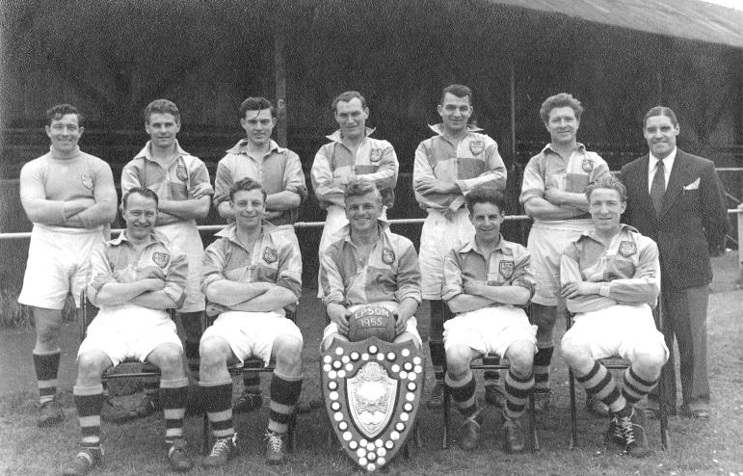
The competition had been renamed by this point and was presumably no longer for Charity but the standard of the teams had also dropped. We had kicked off in the February of 1955 with a 3-0 win over McLaren Sports, a Surrey Senior League team that would change their name in the sixties to Petter Sports and were based in Egham. Ernie Watkins (with Shield) Captains the team to victory

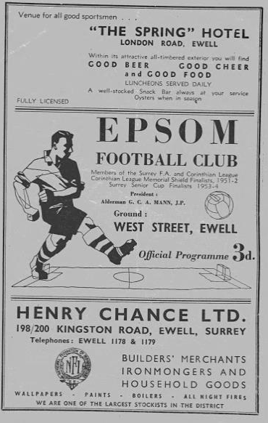
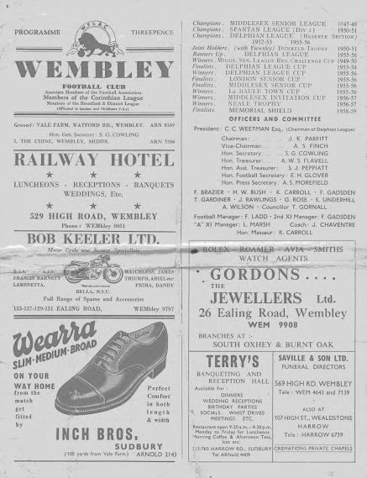
Another team from that League were met in the Semi-Final in our old friends from Camberley and Yorktown as they were then known, where three second half goals turned the match around into a 3-1 win. In the Final, it was our local rivals that were defeated 1-0 at West Street but this was a very disappointing season. Our Manager Pat Lynch had just resigned and our club had just finished bottom of the Corinthian League for the first time, as had the Reserves. This was also the last time that we ever beat Carshalton Athletic!

Programme left is the Carshalton Athletic match and the programme on the right is the Memorial Shield Final v Maidenhead United

Saturday 30th April 1960 – Corinthian Memorial Shield – Epsom FC 2-0 Maidenhead United

This one was all about revenge. We had been in two previous finals of what was the Corinthian League’s League Cup, losing to Hounslow in 1952 and then in 1957 to Maidenhead United. Three years we met the Magpies at Wembley’s Vale Farm and this time it was our turn to win by the same score as we had lost in

the previous final. Steve Dunwoody was allowed leave from his National Service to play and he scored twice to win the match. We had won 3-1 at Erith & Belvedere in the First Round and this was the only goal we would concede as Leatherhead (4-0) and Letchworth (5-0) were dispatched at West Street in the Quarter and Semi-Final respectively.
Peter Wood (with Shield) Captains the team to victory (below)

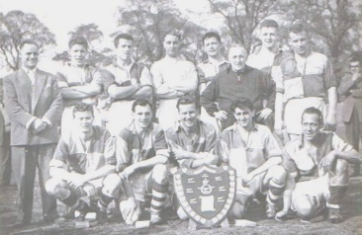

Wednesday 1st May 1974 – Surrey Senior League Cup – Epsom and Ewell 2-1+ Malden Town

Our first season back in the Surrey Senior League after many lean years in the Athenian League, was quite a successful one. Although most people quite rightly think of the 1974/75 season as our high water mark, this season, the first under Pat O’Connell’s Management was quite good too as we finished Runners-Up in the League and then won the League Cup with this extra time victory.

We won 3-0 at Frimley Green in the February of 1974 and then edged our way past Chobham 3-2 at West Street to reach the Semi-Final where we had to visit Wandsworth and required an extra time winner from Colin Rose after the teams had been level at 1-1 after 90 minutes. The Final at Stompond Lane, the old home of Walton & Hersham was goalless after 90 minutes and it was full back Alan Webb that broke the deadlock with Rose scoring a second before a late consolation.

Wednesday 23rd April 1975 – Surrey Senior Charity Cup – Epsom and Ewell 3-1 Virginia Water

This Final was played at Fetcham Grove, Leatherhead and because of our hugely successful season, had played at Wembley Stadium just four days previously and then won 9-0 at Whyteleafe on the Monday! To reach the Final we had beaten Chobham once again, this time 3-0 at West Street, and won 3-1 at Worplesdon and 3-0 at Horley Town in the Semi-Final. The Final was against the only team that had defeated us in the League all season, and Virginia Water managed to score against us on all three occasions that we met, which was no mean feat in a season of such dominance, although it should be pointed out that their goal in this final came from their only shot on target, a penalty awarded four minutes from time. In both of these seasons there was the Charity Cup available, the cup we had won back in 1927, but our hopes of winning it again were ended in a Semi-Final replay to Malden Town in 1974 and then by Chessington United 4-3 in the 1975 Final.

Monday 20th April 1981 – Surrey Senior Cup – Epsom and Ewell 2-1 Woking

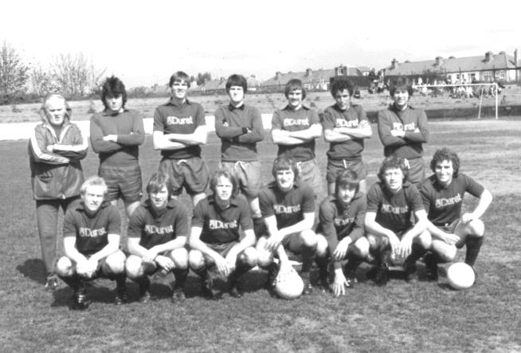
Arguably the greatest win in the club’s history, we won the Surrey Senior Cup for the first and so far only time with a 2-1 win over Isthmian League Premier Division Woking at Sandy Lane, home of Tooting & Mitcham United. We were a good team that season and missed out on promotion that season only to three time F.A. Vase winners Billericay Town and F.A. Trophy winners Bishops Stortford, although neither of those teams beat us in either of their League fixtures.

Our journey started back in the final Qualifying Round in December of 1980 when we scraped past Surrey Senior League Westfield 2-1 with an own goal, but then cruised past Ash United 6-0 on their own patch before meeting Walton & Hersham who were defeated at West Street 4-2 in a replay after a 1-1 draw. Then in the Semi-Final we beat the other F.A. Trophy Finalist that season, Sutton United 3-2 also in a replay after drawing 0-0 at Gander Green Lane.

In the Final, goals from Tommy Tuite and Mick Stratford gave us the lead and the opposition were down to ten men after this for violent conduct but pulled a goal back with ten minutes remaining. It didn’t matter though as Woking were overrun and we were deserved winners.

Friday 10th May 2013 – Combined Counties League Cup – Epsom and Ewell 3-0 South Park

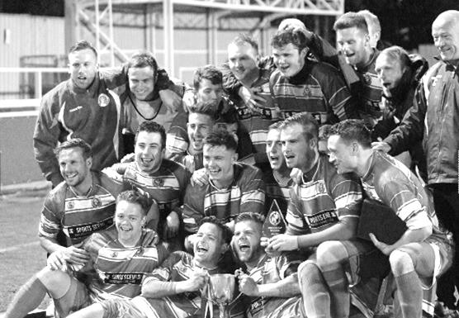
We had to really earn this one, our first trophy for 32 years, the hard way, from a 3-2 victory with ten men at Farnham Town in the First Round to a 3-0 win at Bedfont Sports and then a 2-0 win over the holders Guernsey in the last 16, before easing past AFC Croydon Athletic 6-2 and defeating League Champions Egham by a goal to nil on their own patch despite again finishing with ten men. In the Final, goals came from our joint strike force of Robbie Burns and Kyle Hough in the first half before a superb strike by Sam Currie in the second half eased any remaining nerves.

Can we win a new trophy next week? You’ve surely got to be there to see it!

EL Records Premier Challenge Cup
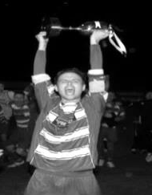
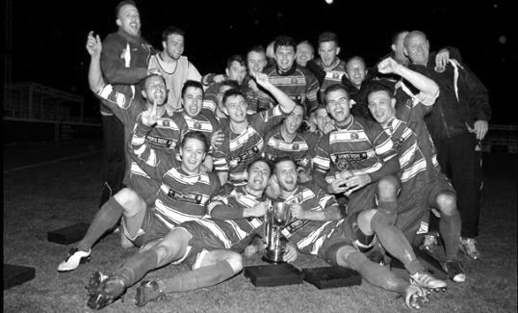
Second Round
Bedfont & Feltham | 2-0 | Tooting Bec
Sheerwater | 1-0 | Balham
Ash United | 2-3 | Fleet Spurs
Frimley Green | 0-2 | Guildford City
Godalming Town | 2-0 | Dorking Wanderers Reserves
Abbey Rangers | 3-0 | Redhill
FC Deportivo Galicia | 5-0 | AC London
Cobham | 0-3 | AFC Hayes
CB Hounslow United | 4-1 | Badshot Lea
Hanworth Villa | 2-1 | Sandhurst Town
Epsom & Ewell | 1-0 | Bagshot
Sutton Common Rovers | 4-2 | Southall
Chertsey Town | 3-2 | British Airways
Eversley & California | 1-5 | Knaphill
Banstead Athletic | 4-3 | Colliers Wood United
Spelthorne Sports | 2-1 | Raynes Park Vale
Third Round
FC Deportivo Galicia | 0-2 | Sutton Common Rovers
AFC Hayes | 0-1 | Bedfont & Feltham
Epsom & Ewell | 5-1 | Godalming Town
Sheerwater | 0-3 | Banstead Athletic
Guildford City | 0-2 | CB Hounslow United
Spelthorne Sports | 0-1 | Hanworth Villa
Knaphill | 3-1 | Fleet Spurs
Chertsey Town | 1-2 | Abbey Rangers
Quarter Finals
Abbey Rangers | 3-1 | Epsom & Ewell
Knaphill | 0-3 | Bedfont & Feltham
Sutton Common Rovers | 3-0 | Hanworth Villa
CB Hounslow United | 2-1 | Banstead Athletic
Semi Finals
Abbey Rangers | 0-4 | CB Hounslow United
Bedfont & Feltham | 0-1 | Sutton Common Rovers
Final at Stag Meadow – Windsor FC – Saturday 11th May
CB Hounslow United | V | Sutton Common Rovers

Buildbase F.A. Vase
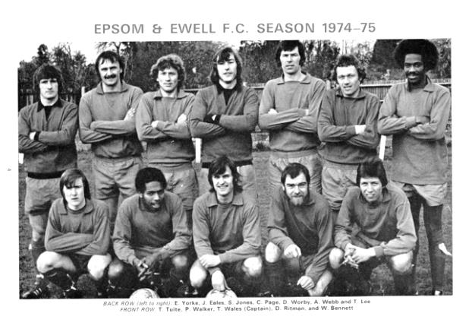

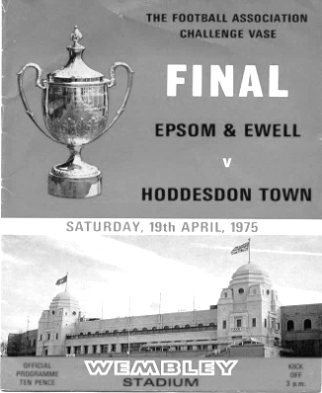
Fourth Round
Godmanchester Rovers | 1-0 awarded to SK | Sporting Khalsa
Irlam | 4-0 | Cadbury Athletic
Hebburn Town | 2-1 | Shepshed Dynamo
Newcastle Benfield | 2-3 | Northwich Victoria
Sunderland RCA | 0-1 | West Auckland Town
Coventry United | 3-2 awarded to LN | Leicester Nirvana
Deeping Rangers | 4-0 | Eastwood Community
Histon | 2-1 | Lye Town
Willand Rovers | 1-0 | Hamworthy United
Canterbury City | 3-2 | Newport Pagnell Town
AFC Uckfield Town | 1-4 | Windsor
Cribbs | 0-2 | Sholing
Bearsted | 1-2+ | Abbey Rangers
Chertsey Town | 5-0 | St Austell
Biggleswade | 1-0 | Stowmarket Town
Cray Valley (PM) | 3-1 | Baffins Milton Rovers
Fifth Round
Irlam | 0-2 | Chertsey Town
Cray Valley (PM) | 3-1 | Abbey Rangers
Histon | 1-3+ | Northwich Victoria
Sholing | 3-1 | Sporting Khalsa
Hebburn Town | 0-2 | West Auckland Town
Biggleswade | 6-1 | Windsor
Willand Rovers | 3-2 | Deeping Rangers
Canterbury City | 2-1 | Leicester Nirvana
Quarter-Finals
West Auckland Town | 0-2 | Chertsey Town
Canterbury City | 2-1 | Biggleswade
Willand Rovers | 1-3 | Cray Valley (PM)
Northwich Victoria | 3-1 | Sholing
Semi-Finals – Two legs
Northwich Victoria | 1-1 0-0 p3-5 | Chertsey Town
Cray Valley (PM) | 1-0 1-1 | Canterbury City
Final - 19th May at Wembley Stadium
Cray Valley (PM) | V | Chertsey Town

Almost Complete Result Grid
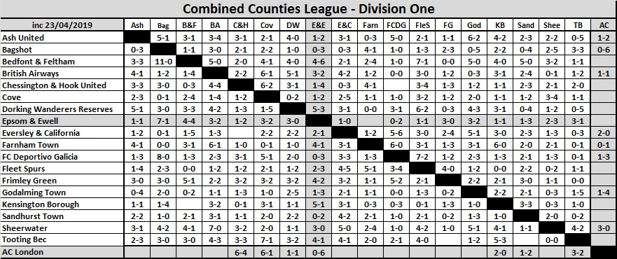

Combined Counties League Division One
Opponents All-time Records
incl Saturday  20th April | P | W | D | L | F | A | PPG | GD | Best  Win | Worst  Loss
Bagshot | 3 | 3 | 0 | 0 | 11 | 1 | 3.00 | +10 | 7-1 | -
AC London | 1 | 1 | 0 | 0 | 6 | 0 | 3.00 | +6 | 6-0 | -
Bedfont & Feltham | 5 | 4 | 1 | 0 | 25 | 12 | 2.67 | +13 | 9-2 | -
Godalming Town | 6 | 5 | 0 | 1 | 15 | 9 | 2.50 | +6 | 5-1 | 0-3
Frimley Green | 12 | 9 | 1 | 2 | 37 | 9 | 2.33 | +28 | 7-1 | 2-4
FC Deportivo Galicia | 3 | 2 | 0 | 1 | 7 | 4 | 2.00 | +3 | 3-0 | 0-2
Fleet Spurs | 2 | 1 | 1 | 0 | 4 | 3 | 2.00 | +1 | 3-2 | -
Ash United | 21 | 11 | 4 | 6 | 50 | 32 | 1.76 | +18 | 6-0 | 0-3
Farnham Town | 18 | 9 | 4 | 5 | 31 | 29 | 1.72 | +2 | 3-0 | 1-4
Cove | 36 | 17 | 9 | 10 | 80 | 58 | 1.67 | +22 | 7-0 | 1-6
Chessington & Hook | 30 | 13 | 9 | 8 | 63 | 45 | 1.60 | +18 | 6-0 | 1-3
Dorking Wanderers Res | 2 | 1 | 0 | 1 | 6 | 5 | 1.50 | +1 | 3-0 | 3-5
British Airways | 2 | 1 | 0 | 1 | 5 | 5 | 1.50 | 0 | 3-2 | 2-3
Eversley & California | 2 | 1 | 0 | 1 | 2 | 2 | 1.50 | 0 | 1-0 | 1-2
Tooting Bec | 2 | 1 | 0 | 1 | 4 | 5 | 1.50 | -1 | 3-1 | 1-4
Sheerwater | 6 | 2 | 2 | 2 | 10 | 8 | 1.33 | +2 | 3-0 | 0-3
Sandhurst Town | 17 | 7 | 0 | 10 | 29 | 31 | 1.24 | -2 | 4-0 | 1-3
Kensington Borough | 2 | 0 | 1 | 1 | 2 | 6 | 0.50 | -4 | - | 1-5

Combined Counties League – Division One
Saturday, 27th April 2019 - Kick-off 3.00 p.m.
Epsom and Ewell  (Royal Blue & White hoops) | V |  | Farnham Town  (Claret / Sky Blue)
Squad | NUMBERS |  | Squad
Conor Young |  |  | Dease Kerrison
Josh Woodcock |  |  | Max Meaton
Louis Chin |  |  | Tom Smith
Luke Elgar |  |  | Walter Verkaik
Reisse Griffin |  |  | Kay Conteh
Lloyd Connelly |  |  | Harry Oakley
Jamie Watts |  |  | Nick Medcraft
Adam Heagney |  |  | Kye Nash
Sam Morgan |  |  | Sam Gillett
Todd Murphy |  |  | Matt Glass
© Scott Murphy |  |  | Elliot Cardona
Elliott Thompson |  |  | Jack Falvey
Ryan Sullivan |  |  | Ashley Peck
Bobby Bennett |  |  | Rowan Sharratt
Rob Hendry |  |  | Otis Taylor
Liam Roberts |  |  | Sean Evans
Olly Martinez
Jake Robinson
Hakim Griffiths
Ben Chick
Billy Carney
Simon Funnell | MANAGER |  | Luke Turkington
Matt Drew / Paul Marshall | ASSISTED BY
Matt Drew | COACHES
Chantelle Farrell | PHYSIO
REFEREE: B.Wright
ASSISTANTS: J.Lidbetter, P.Maskell
Today’s match and match ball are sponsored
in memory of Chris Henry (RIP)

Thank You for your support this season!

See you in August 2019!

